From a Google Chrome or IE Edge Browser type WWW.Workforcenow.adp.com
Designated PCs have IE Edge on the desktop – click the IE Edge icon on the desktop to access the browser

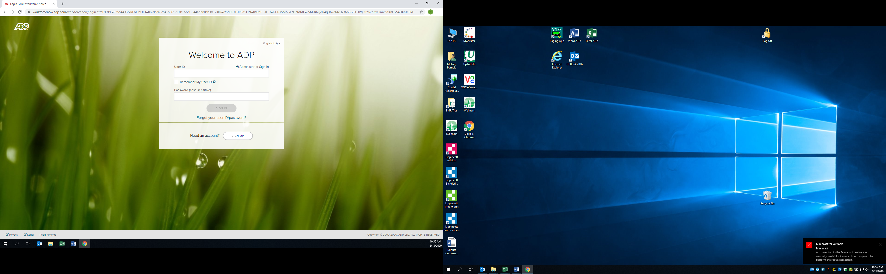
Enter Your user id and Password
User ID – first initial last name @brattretrt
ex. mmouse@brattretrt
Password – user created password

Forgot User ID or password or locked out?
Click Forgot your user ID/password

Follow instructions below to reset your password

Type Your First Name
Type Your Last Name
Type your Brattleboro Retreat email
Click Next
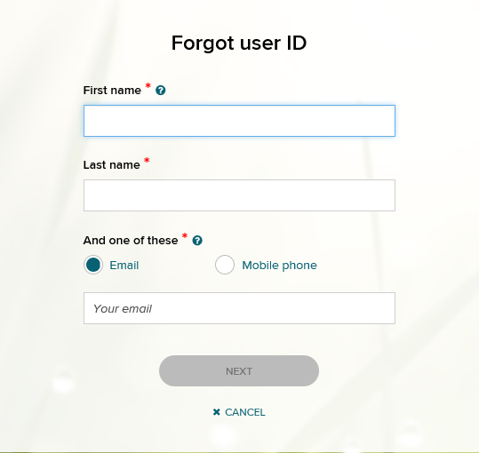
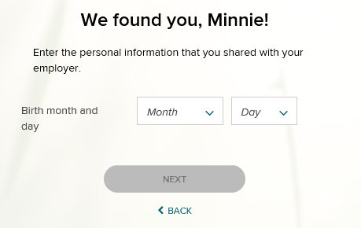
For additional protection, you may be asked to identify
Month and Day of Birth
or
Last 4 digits of your Social Security Number
Click Next
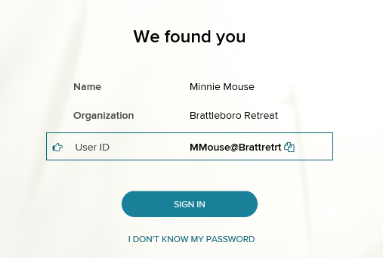
The system finds you
Click I DON’T KNOW MY PASSWORD
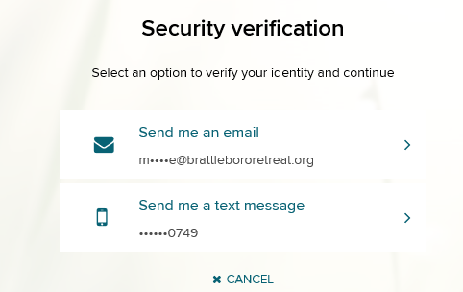
ADP will send you a security verification code to enter before you can proceed
Click on the email address or phone number you would like the code sent to
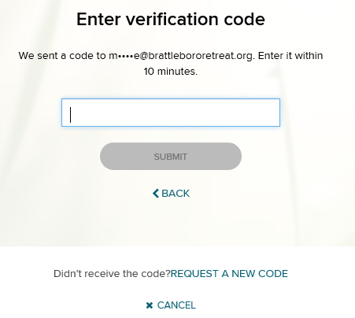
DO NOT CLOSE THIS SCREEN

Enter the code sent to you by ADP into this screen

Click Submit
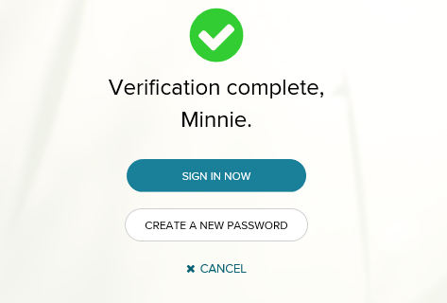
You will receive this message that verification is complete
Click CREATE A NEW PASSWORD

Create a new password
You cannot use the same one you have used in the past

Type your new password
Type your new password again to confirm

Click SUBMIT
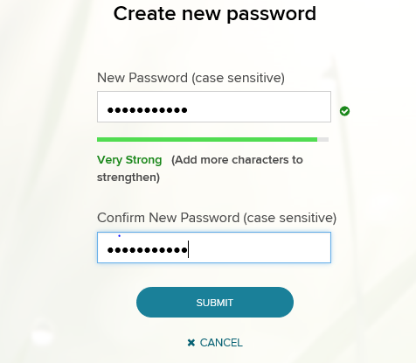
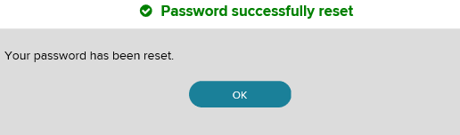
You will receive a message that you were successful

