Dear Employee,

We are excited to announce the start of Open Enrollment on the *Employee Self Service*\* website.

This letter explains what you need to do to complete your enrollments. The Open Enrollment period will last ***11 days*** starting ***Tuesday, November 4, 2020***and ending ***Saturday, November 14, 2020.***  All changes to your benefits must be completed by **11:59pm,** ***Saturday, November 14, 2020. The*** changes that you make to your benefits will take effect on ***Friday, January 1, 2021***.

Access the Employee Self-Service website using Google Chrome or IE Edge by typing <https://workforcenow.adp.com>.

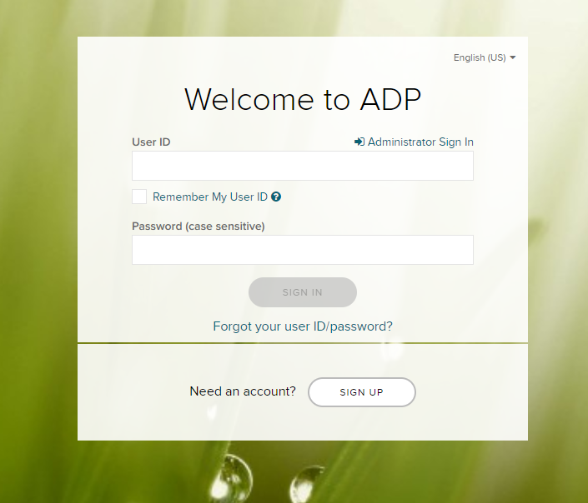

Enter your User ID and password, and then click **Sign In**.

**Note:** If you do not know your user ID or password, refer to the reset user id and password instructions.

Upon logging in, you will be presented with a pop-up showing important information about this Open Enrollment period. You can click **Start This Enrollment** or **Remind Me Later**. This pop-up is displayed each time you log in during the Open Enrollment period until you complete your selections.

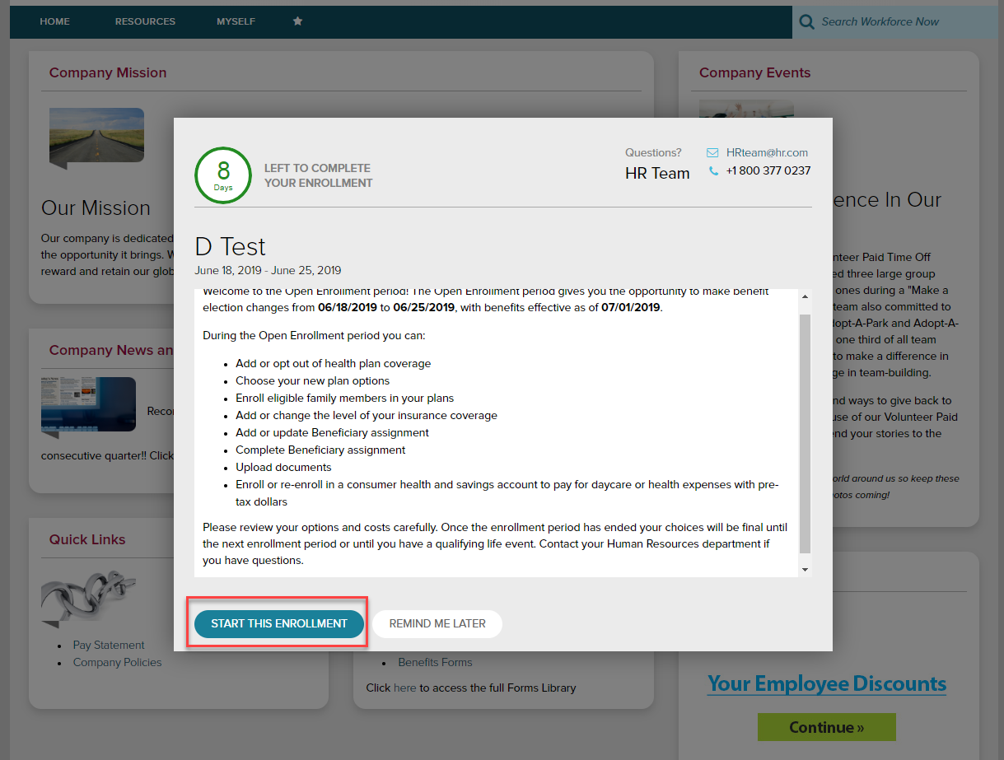

To start, click **Enroll Now** in the Open Enrollment card. You will be brought back to the Welcome Note and Introduction page. Please review all information on this page, as there are often important references for your Open Enrollment options. If any tobacco attestation requirements are in place, you must provide the information as indicated before clicking **Continue**.

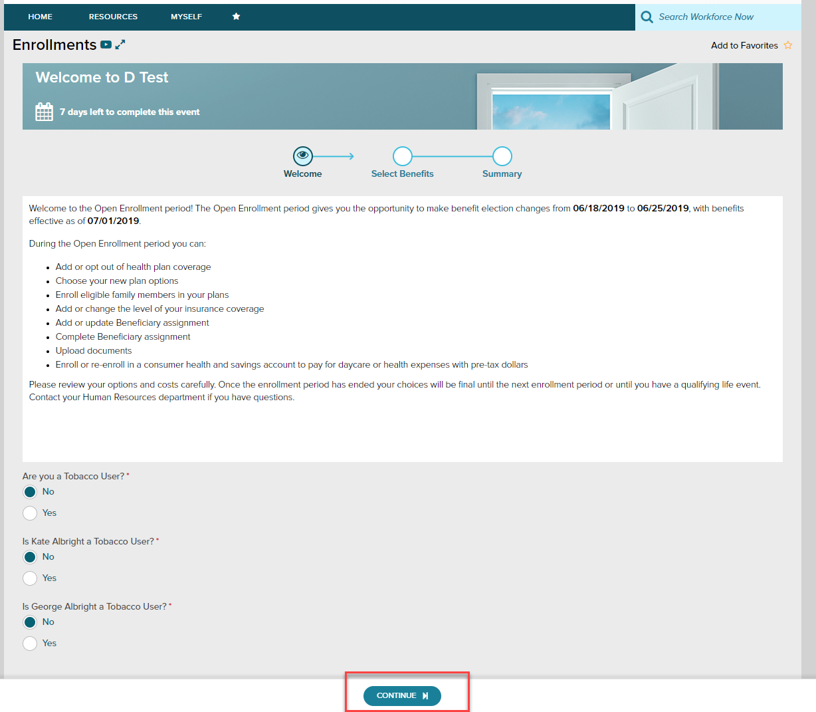

The left side of the screen will indicate the different plan types that are available to enroll in. When you are viewing the selected plan type, all enrollment options will be displayed on screen.

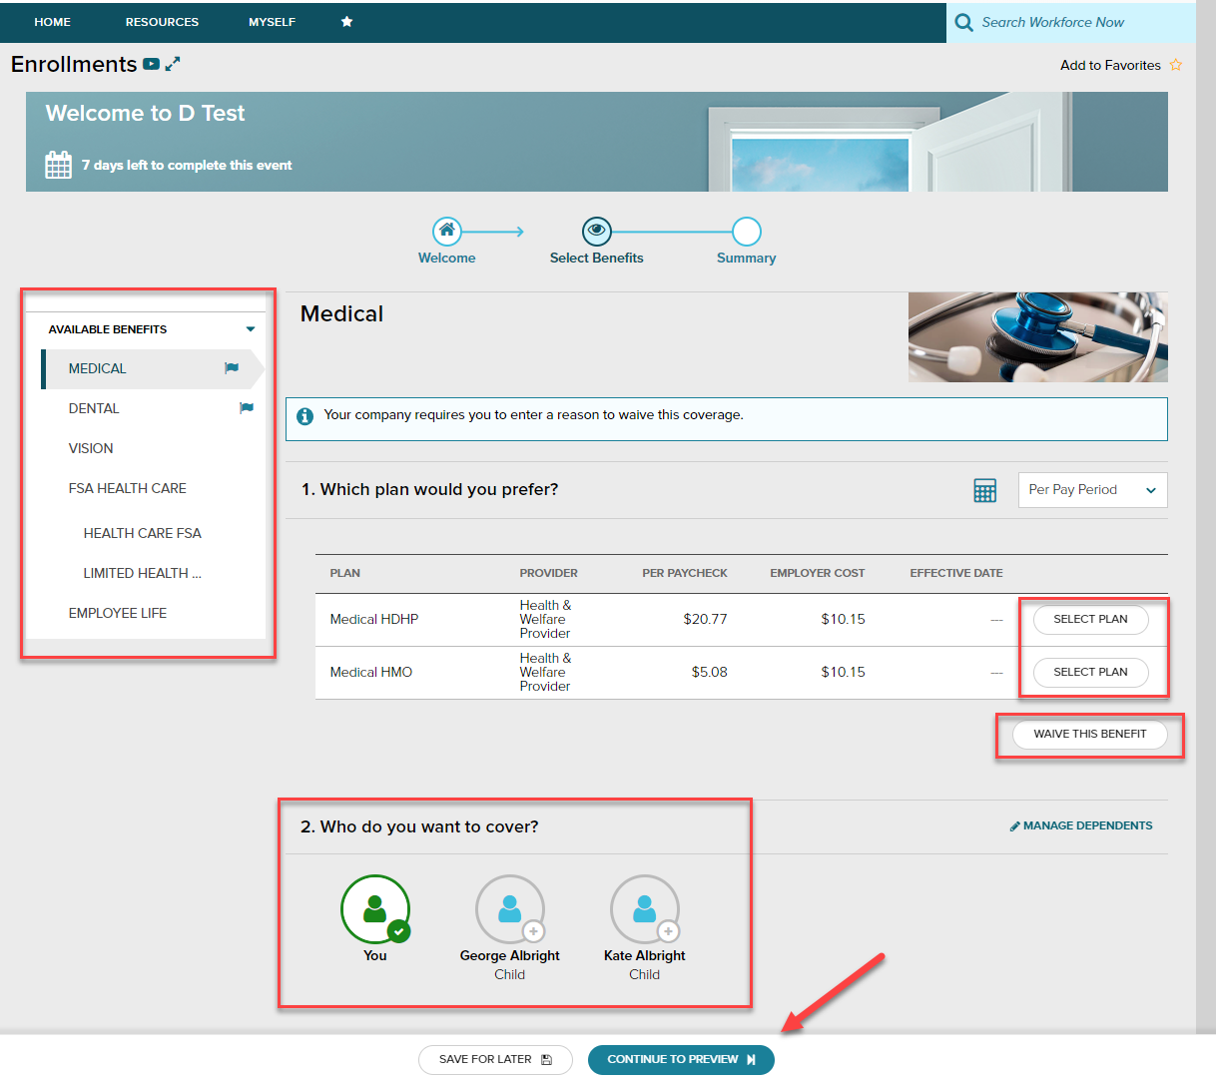

You may choose to click **Select Plan** for the desired enrollment or **Waive This Benefit**. If you choose to waive a benefit, you may be required to select a waive reason.

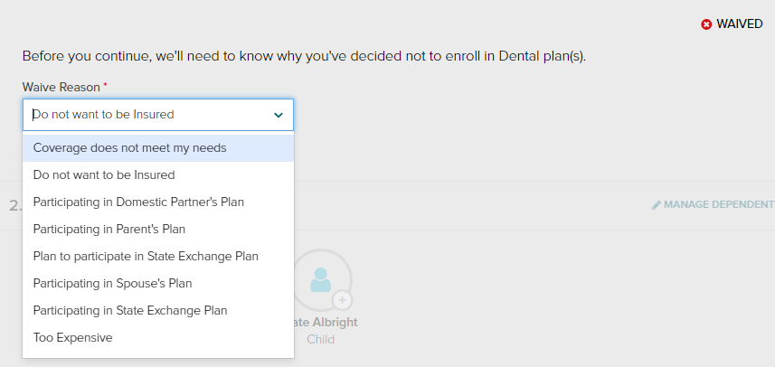

When you choose to enroll in a plan, you may review your costs on a **Per Pay Period**, **Monthly**, or **Annual** basis by selecting the desired view in the calculator drop-down. The rate displayed to the left will be updated based on your selection, and it will also be updated if dependents are added for coverage.

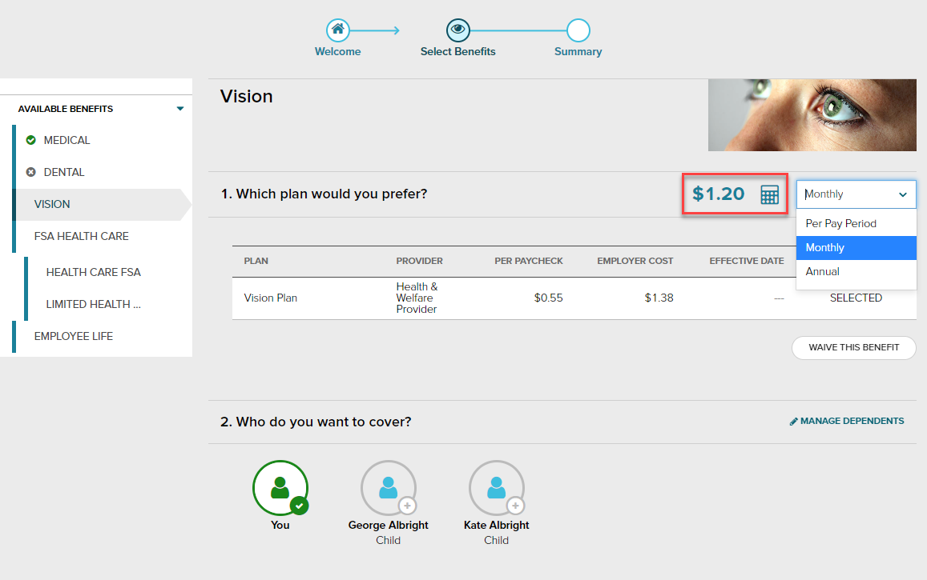

While enrolling in a plan, please be sure to indicate which dependents should be covered in Step 2, if applicable. If you need to update or add a dependent, you may click the **Manage Dependents** link in step 2.

*Please note: The coverage level for your enrollment (Employee Only, Employee + Spouse, Employee + Child(ren), Employee + Family) is driven by which dependents you select to enroll.

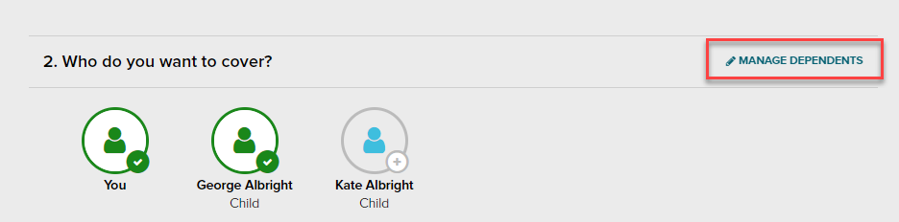

Click **Continue to Preview**.

Review your enrollment, costs, and covered individuals carefully. Then click **Save and Continue to Next Benefit** to continue making your desired selections.

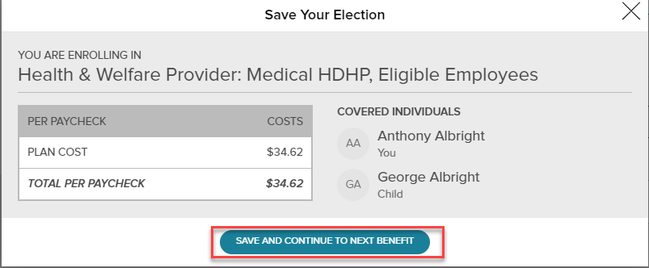

**Voluntary Life Elections and Beneficiaries:**

When you elect Voluntary Life, you will also need to select your beneficiaries.

Start by clicking **Select Plan**, and then choose the amount of coverage you want to elect.

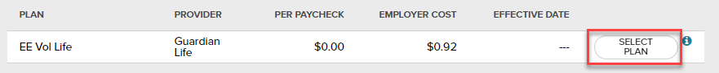

If the amount selected is over the Guarantee Issue amount, an approval will be required and you will be asked to collect an **Evidence of Insurability** (EOI) and submit it to your employer. Your full election amount will not be approved until this document is received.

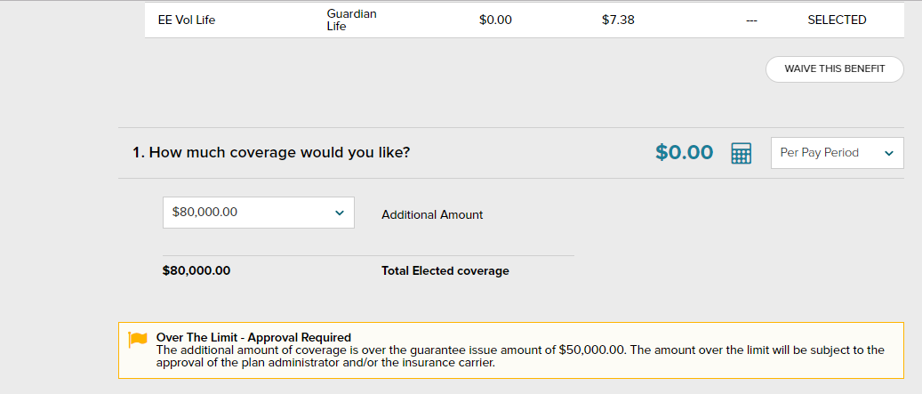

Next, select your **beneficiaries**, including **Primary** and **Secondary**, if applicable. All beneficiary delegation percentages combined must equal 100% for each category (Primary or Secondary).

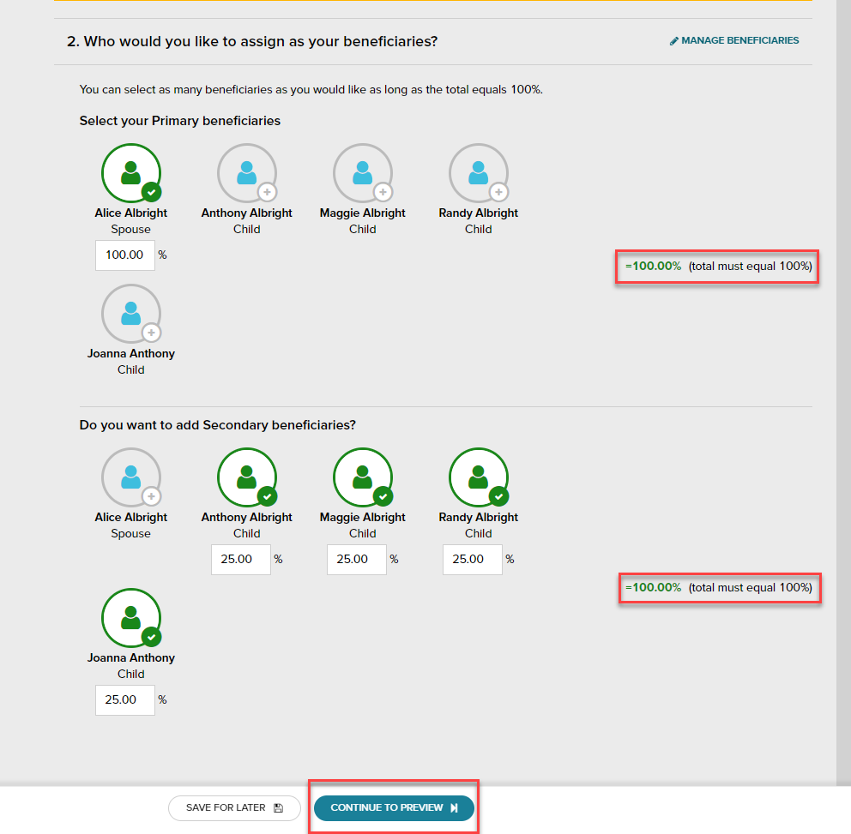

Click **Continue to Preview** and review your selection and beneficiary delegations.

Then click **Save and Continue to Next Benefit**.

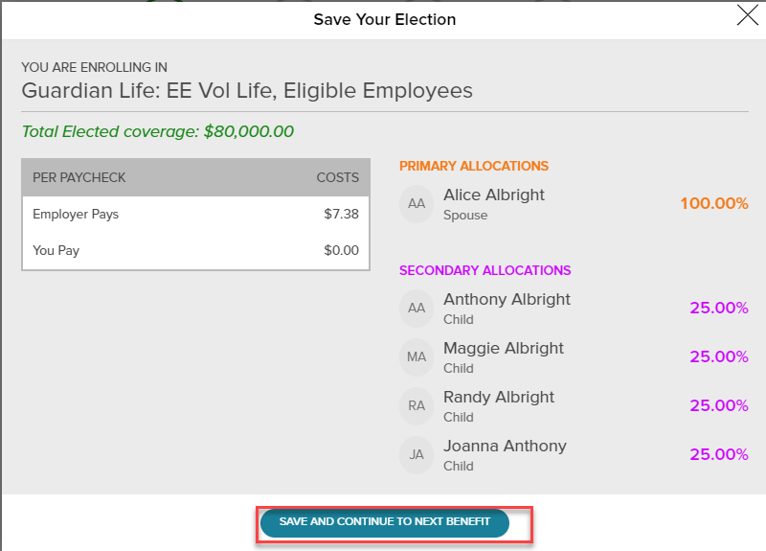

In the Open Enrollment flow, the following visual indicators are displayed to show different steps taken, action items, or enrollment statuses:

|  |  |
| --- | --- |
| **Symbol** | **Meaning** |
| * (flag icon) | The plan needs your attention. |
| (green check mark) | This is a current plan that you are enrolled in. |
| (gray X) | This plan has been waived. |
| ( orange clock icon) | This plan is pending approval. |

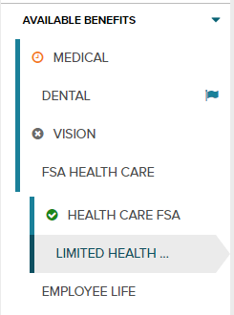

Continue through each step until all elections are complete and the **Continue to Summary** button is activated.

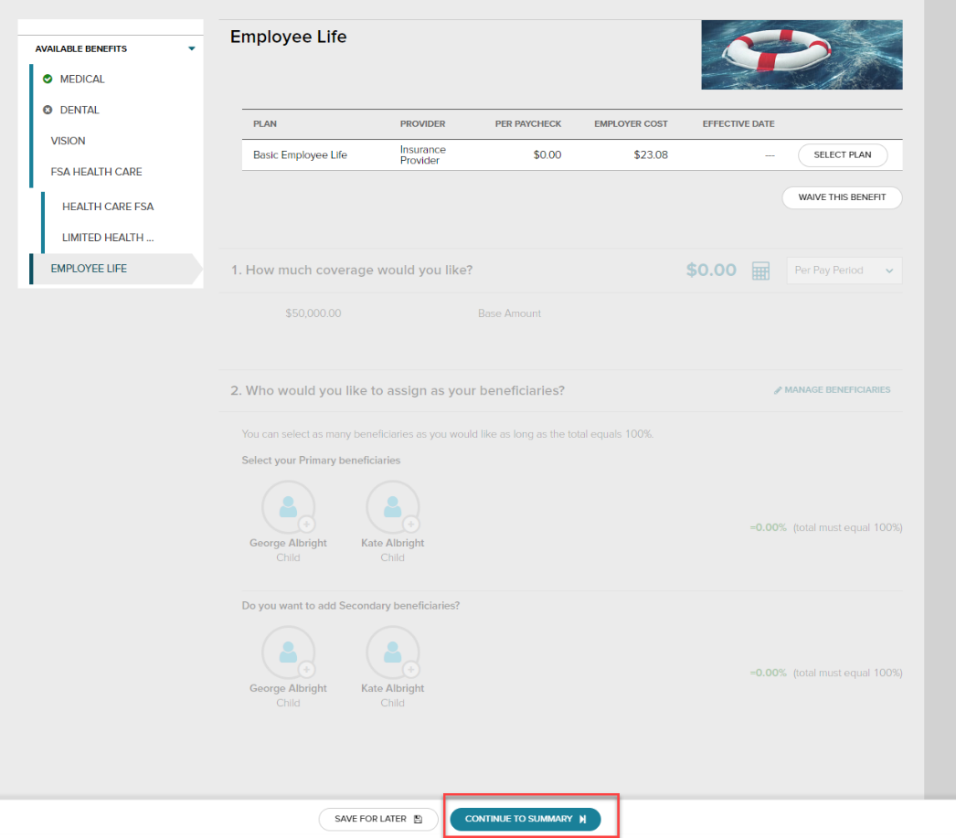

Review all of your selections. When you have confirmed them, click **Submit Enrollment**. Note that your benefit elections will not be processed until you click **Submit Enrollment.** If you click **Save for later** instead, these enrollments will not be submitted to your HR team until you fully submit the enrollment.

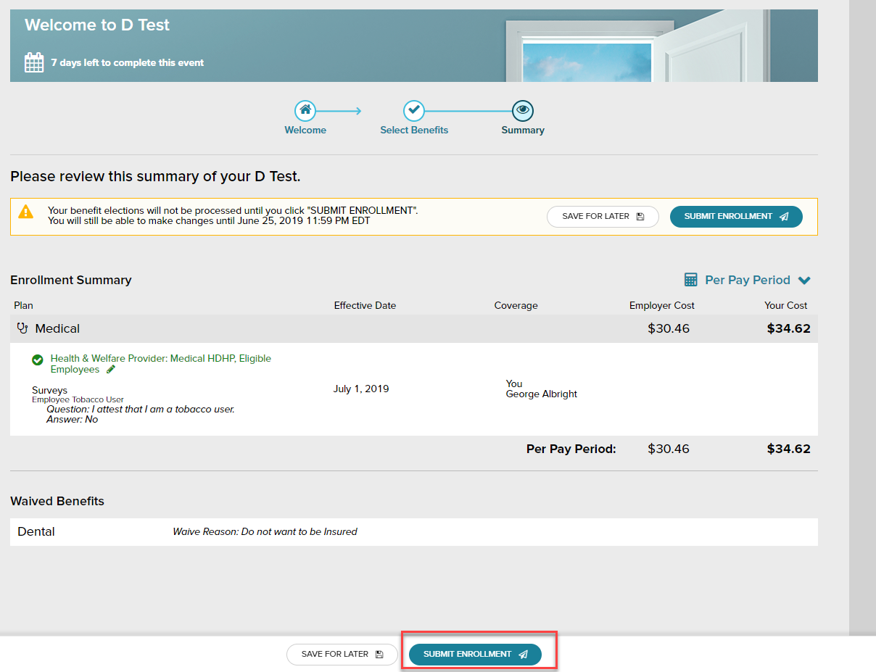

Please ensure you receive the confirmation note indicating your elections have been submitted.

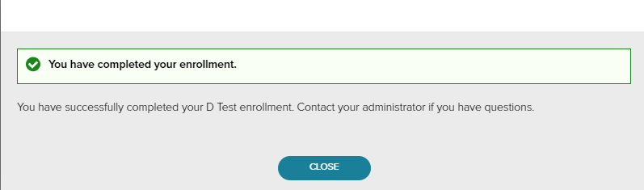

If you would like to make additional changes or modifications during the Open Enrollment Period, you may log in and navigate to **Myself > Benefits > Enrollments** and click the **Enroll Now** option again in the Open Enrollment box, which will bring you back to the beginning of the profile to make any desired election changes.

