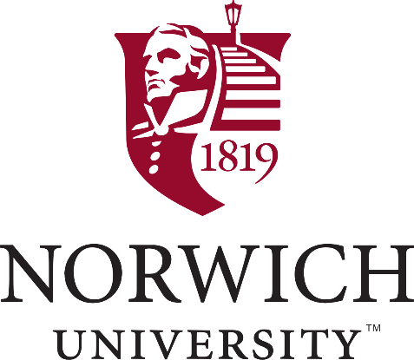

Wellness Ambassador

A Wellness Ambassador supports the Norwich University's wellness team to communicate with the faculty and/or staff about wellness initiatives, programs, events, and resources within his/her department, and across campus.
An Ambassador is enthusiastic about health and well-being, thinks beyond themselves, believes in the strength of community, and seeks to foster a healthy culture within the environment around them.

What will my responsibilities be?
In conjunction with Wellness Committee, the Wellness Ambassador will
- Participate in and encourage others to participate in well-being programming sponsored by Norwich and by the Green Mountain Higher Education Consortium.
- Communicate to colleagues about campus and GMHEC well-being initiatives, programming, events and resources.
- Be the Wellness committee first point of contact within your department, and be ready to speak at Department meetings about opportunities to participate in the Norwich Wellness program.
- Receive and disseminate communications about health and wellness at Norwich, and provide feedback on past/future initiatives.

What are the benefits of becoming a Wellness Ambassador?
- Opportunity to be the "first to know" on the latest Wellness at Norwich University, resources and events to communicate to your colleagues.
- Embody two of the Norwich University guiding values of encouraging service to others before self, and stressing “being physically fit and drug free.”

How do I become a Wellness Ambassador?
- Review the NU Wellness Program information (Link: http://norwich.trgportal.com/wellness-2/)
- Sign up today by contacting nuhr@norwich.edu with the following information:
  - First and Last Name
  - Department
  - Contact info
  - Brief statement on why you want to be a Wellness Ambassador

