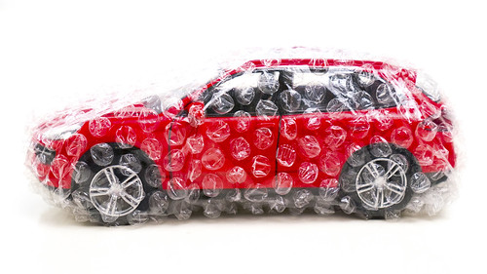

REIMBURSEMENT REQUEST FORM

**Car Seat Cover Reimbursement Program**

Employee Name: **Click here to enter text.**

Employee ID number (Rater Code): **Click here to enter text.**

Cost of Covers Purchased: **Click here to enter text.**

Date Purchased: **Click here to enter a date.**

Original Itemized Receipt Attached

* For staff who transport clients in personal staff vehicles
* Up to $50 reimbursed (grossed up)
* For car seat covers to protect against wear and tear, as well as accidents and damage to car seats

Employee Signature: _______________________________________

Please return this form to Kait in HR, kskogsta@hcrs.org, or fax to 802-886-4530.

**HR USE ONLY:**

Date Received _____________________________ Date Paid: __________________________