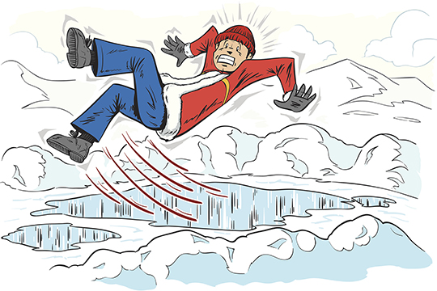

2022-2023

Yaktrax or Ice Gripper Stipend Form

Name:  Rater code:

I certify that I purchased a pair of either:

\* Yaktrax or similar style, Ice Grippers, or other traction cleats for my boots, for a reimbursement of up to $15. I have attached a copy of the receipt to this form.

\* Microspikes ice grippers for my boots/shoes, for a reimbursement of up to $35. I have attached a copy of the receipt to this form.

HCRS will reimburse you for up to $15 towards your purchase of Yaktrax or similar style; or up to $35 for Microspikes or similar, to be provided in your next paycheck. This is a taxable benefit.

Signed or typed name

Date

*Please email the completed form to Kait Skogstad in HR at* [*kskogsta@hcrs.org*](mailto:kskogsta@hcrs.org)*. If you have any questions, you can contact Kait at (802) 886-4567 ext. 2165.*