**Applying a New Chapter Company Discount on Verizon Wireless**

# Author: Tara Labor

Verizon Wireless offers all New Chapter employees a 23% discount on the “Access Fee” associated to your plan, as well as a 25% discount on accessories ordered from verizonwireless.com

Here is the link to the website:

[*https://login.verizonwireless.com/vzauth/UI/Login?realm=vzw&goto=https%3A%2F%2Fwww.verizonwireless.com%3A443%2Fod%2Fcust%2Fauth%2Flogout*](https://login.verizonwireless.com/vzauth/UI/Login?realm=vzw&goto=https%3A%2F%2Fwww.verizonwireless.com%3A443%2Fod%2Fcust%2Fauth%2Flogout)

**Step 1.**

If you have not done so already, you will first need to register your VZW account online, by clicking on “Register”

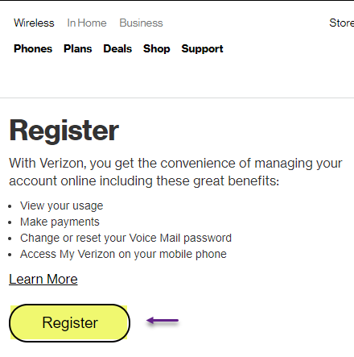

If you have already registered your VZW account online, then you can just sign in as normal.

**Step 2.**

Sign into your Verizon Wireless Account:

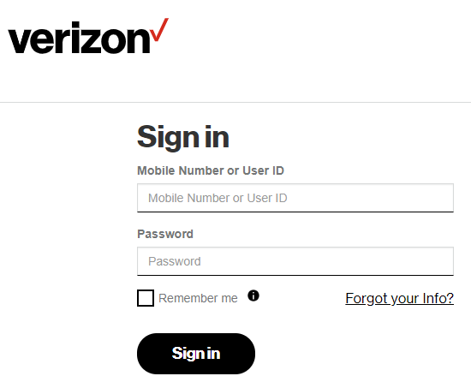

**Step 3.**

Click on the “Account” dropdown, and choose “Discounts”

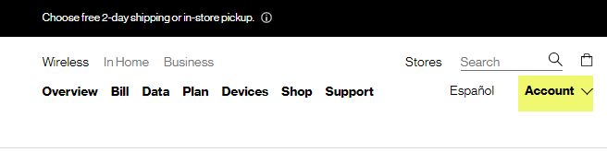

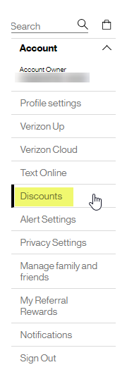

**Step 4.**

On the discount validation screen, click on the link to “Validate with my work email address” link at the bottom of the page:

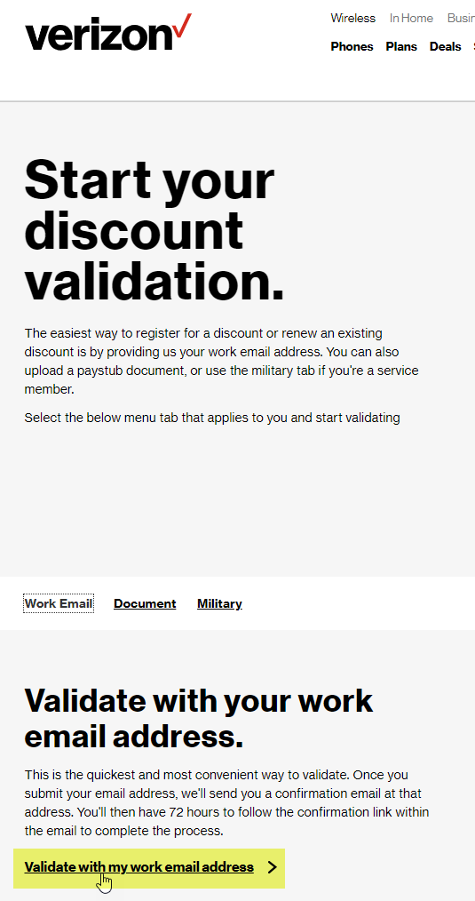

**Step 5.**

Enter your New Chapter work email address, and then confirm that email, and then click the option to “Validate my work email address:

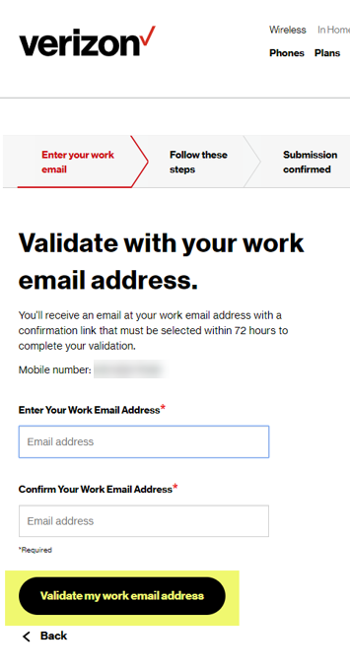

**Step 6.**

Once you click the option to validate your email, you will automatically go to the next page, prompting you to check your email inbox, so that you can complete confirmation process:

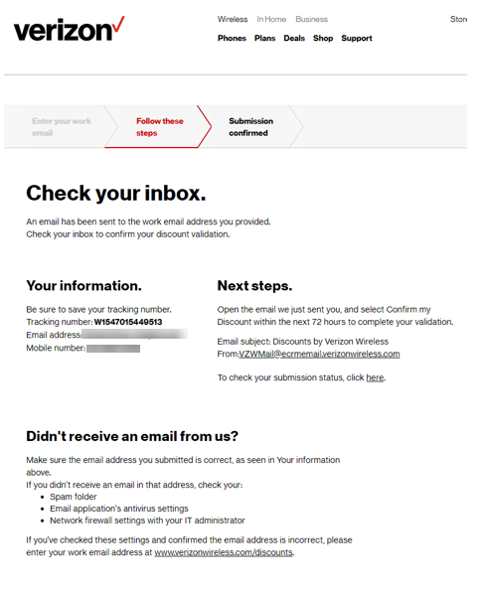

**Step 7.**

In your inbox, you should have an email from Verizon Wireless, which provides you a link to confirm your discount. You will want to do this right away, as the link will expire, and you will have to start all over if it does:

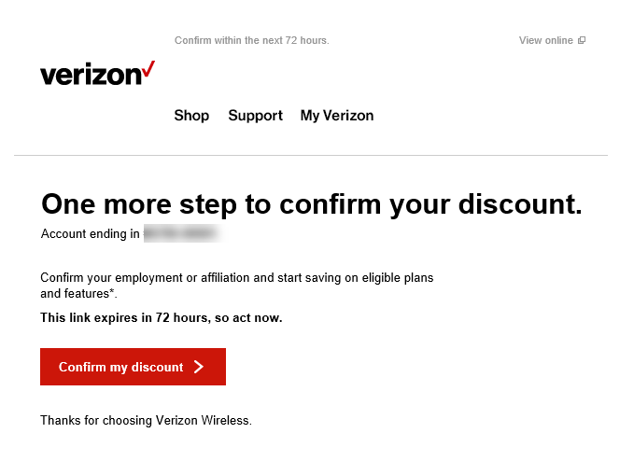

Once you have completed this step, you should receive a confirmation email like the one below. Please red this carefully, as it contains details regarding the discount and future validation that Verizon Wireless requires:

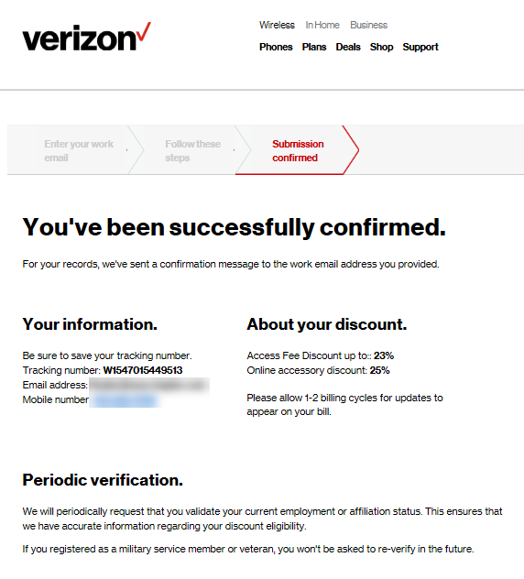

You have now completed the process of adding your New Chapter email address to your Verizon Wireless account, to receive the monthly company discount.