**FEDEX - Employee personal shipments**

Go to Fedex.com

At top of page on the right click on “Login”

Login info: User ID: KABPersonal Password: King1790Arthur

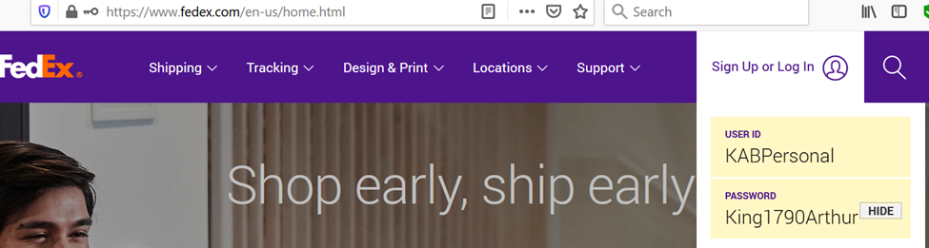

Select “Shipping” -> “Create a Shipment”

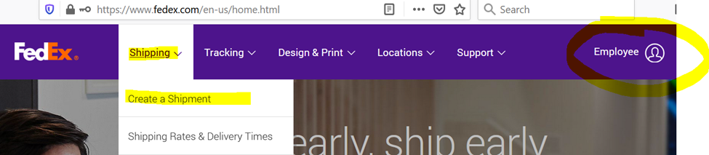

**Section 2 To**: Enter the address for your shipment

**Section 4 Billing Details:**  Be sure to enter your name in the “Your reference” field.

Select Drop off or Use scheduled pick up if you are able to bring to Avalon

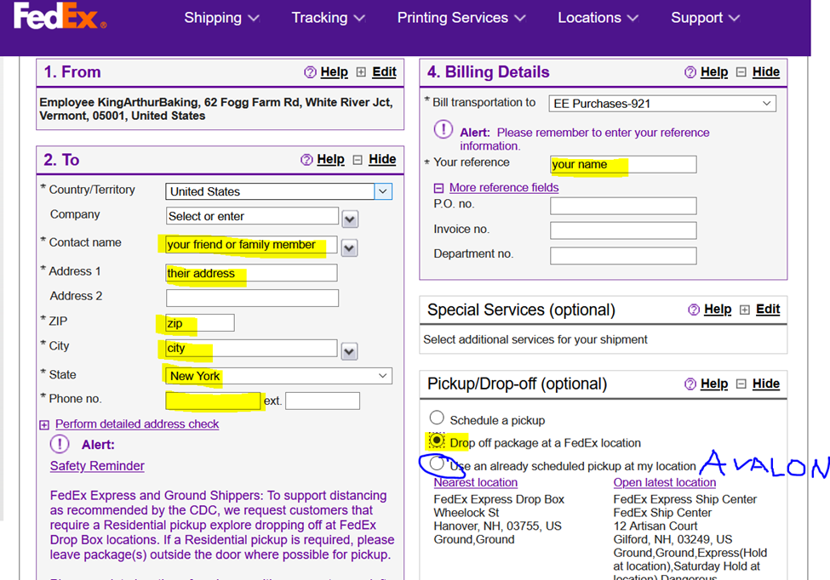

Fill in your desired Shipment notifications and be sure to update the email addresses.

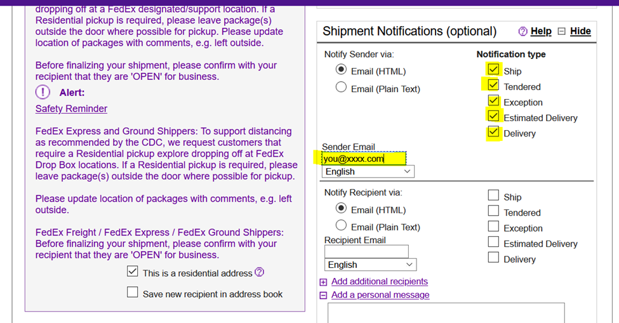

**Section 3 Package & Shipment Details**: Estimate the weight and package dimensions the best you can.

Once you have completed all the necessary fields, click “Calculate” in the “Rates and Transit Time” box to see your shipping options and the cost for each. Adjust shipping method if you wish.

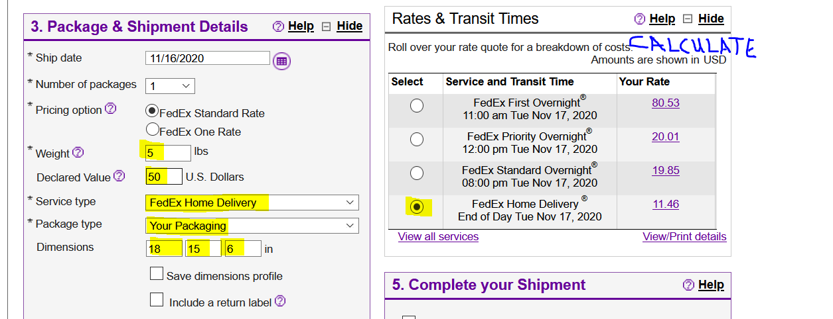

**Section 5 Complete your Shipment**: Click “Ship” at the bottom of the form.

Confirm information at next page.

Click on “Ship” again and you will be directed to where you can print a shipping label and receipt.

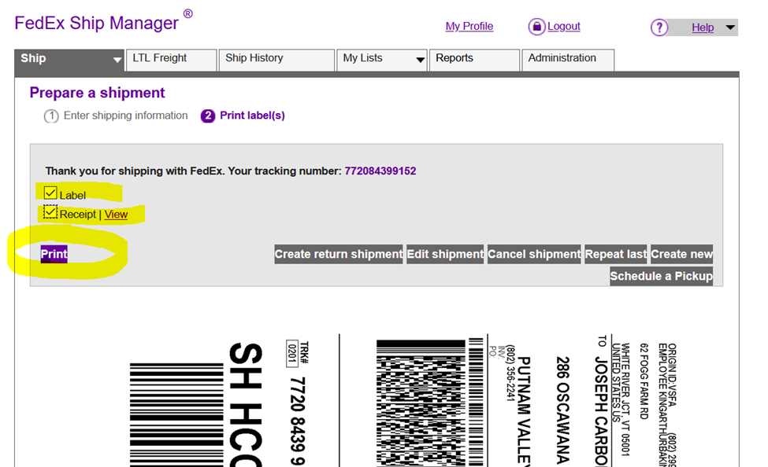

Print label and attach to box with clear packing tape.

Bring the box to your local FedEX drop off location

OR

Drop off at Avalon inside the door (under the mail boxes)

Email [PickPackShip@KingArthurBaking.com](mailto:PickPackShip@KingArthurBaking.com), a lead will ensure your package gets put on the truck.

Send a check to Finance with a copy of your receipt or a notation that you are paying for Fedex personal shipping.

If you encounter issues please notify [Sandy.Sapp@KingArthurBaking.com](mailto:Sandy.Sapp@KingArthurBaking.com) or [Ana.Gallo@KingArthurBaking.com](mailto:Ana.Gallo@KingArthurBaking.com)