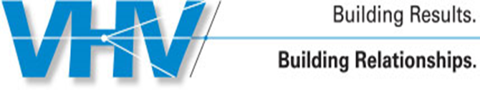
VHV Company

16 Tigan Street, Winooski, VT, 05404
Melinda Friedlander, Plan Administrator, (802) 861-6164

Effective Date: September 30, 2025

Employee & Eligible Beneficiaries,

As an employee of VHV Company and participant in our employee benefit programs, you and your beneficiaries may have various rights and privileges related to these programs. Laws governing health care require us to provide you with these notifications. Listed below are important notices to retain for your records. In the past, many of these notices were sent individually and are now grouped together to more clearly communicate your rights, and to simplify distribution. If you have any questions please contact Melinda Friedlander, VHV Company at: (802) 861-6164

For individuals who elect to waive coverage, some of these notices will not apply to you. See the plan administrator for further details.

IMPORTANT INFORMATION

NOTIFICATIONS

