Accident Insurance

Explore Your Benefits & Costs

**Cleaning the gutters. Yoga class. Soccer practice. Life offers plenty of opportunities for accidental injuries.** **When an injury happens, Accident Insurance can help.** This document includes expanded cost and benefit information for Accident Insurance. As you explore, keep in mind:

Group Name: Valley Regional Healthcare, Inc.

Group Number: 705063

Accident Insurance doesn’t replace your medical coverage; instead, it complements it. **The benefit payments don’t *go out* to pay for medical bills or treatments you may need, instead they *come in*—directly to you— to be used however you’d like.** Choose this supplemental health insurance product for added protection if one of the following covered conditions comes your way.

No medical questions or tests are required for Accident coverage.

Benefit payments go directly to you. Use them how you’d like!

Accident Insurance is a limited benefit policy. It is not health insurance, and does not satisfy the requirement of minimum essential coverage under the Affordable Care Act.

# How much does it cost?

This table shows your rates for Accident Insurance. The cost provided below includes Accident Insurance premium and a fee for Voya Travel Assistance.





Your spouse will be covered for the same Accident benefits as you.

If you have coverage on yourself, your natural children, stepchildren, adopted children or children for whom you are legal guardian can be covered up to age 26. Your children will be covered for the same benefit amounts as you. One premium amount covers all of your eligible children.

# What’s covered?

Accident Insurance provides a benefit payment after a covered accident that results in the specific injuries and treatments listed in this document. Some of the most common treatments and conditions we pay benefits for include:

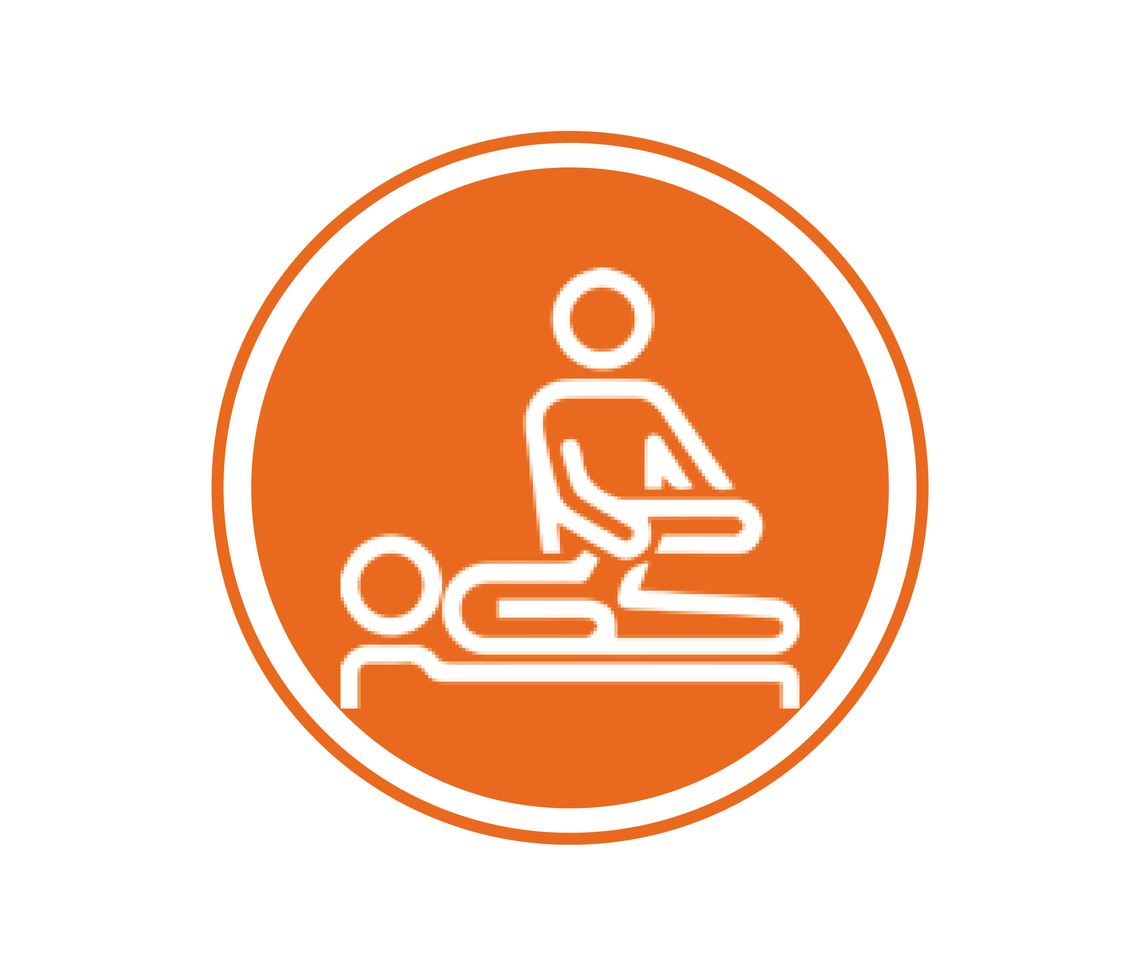

**ER treatment**

**X-rays**

**Physical therapy**

**Stitches**

**Follow-up doctor treatment(s)**

**Sample payment amounts**

If one of these events happens to you, and your claim is approved, you’d receive a benefit payment in the amount listed below. Use it however you’d like:

{seismic} do not delete/modify this hidden paragraph {seismic}

{seismic} do not delete/modify this hidden paragraph {seismic}

|  |  |  |
| --- | --- | --- |
| **Accident-related treatment** | **Standard** | **Enhanced** |
| Emergency room treatment | $225 | $300 |
| X-ray | $75 | $100 |
| Physical or occupational therapy | $45 | $75 |
| Follow-up doctor treatment | $90 | $120 |
| Hospital admission | $1,250 | $2,250 |
| Hospital confinement (per day, up to 365 days) | $275 | $400 |
| **This is only a small preview of the benefits available to you.** | | |
| **See the full Schedule of Benefits toward the end of this document.** | | |

# Additional non-insurance service(s)

**Voya Travel Assistance**

Being in an unfamiliar place can cause stress, especially if something goes wrong. Voya Travel Assistance offers you and your dependents services when traveling 100 miles or more from home, including: medical assistance services, emergency medical transport services, travel assistance services such as pre-trip and cultural information, security services and accessible technology.

*Voya Travel Assistance services are provided by International Medical Group, Inc., Indianapolis, IN.*

Access **extra support** next time you travel

# Schedule of Benefits

The following list is a summary of the benefits provided by Accident Insurance. You may be required to seek care for your injury within a set amount of time. Note that there may be some variations by state. For a list of standard exclusions and limitations, go to the end of this document.

|  |
| --- |
| * **Your coverage includes a Sport Accident Benefit.** This means that if your accident occurs while participating in an organized sporting activity (as defined in the certificate of coverage); the benefit amounts in the accident hospital care, accident care or common injuries sections below will be increased by 25%; to a maximum additional benefit of $1,000. |

New Hampshire

Accident Insurance (ACC2) benefits schedule – Version 1 & 2

For use in customizing “Explore Your Benefits & Costs” (#212309)

| Event | Standard | Enhanced |
| --- | --- | --- |
| |  |  |  | | --- | --- | --- | | **Accident hospital care** |  |  | | |  |  |  | | --- | --- | --- | |  |  |  | | |  |  |  | | --- | --- | --- | |  |  |  | |
| Surgery inpatient other than for dislocation or fracture | $1,500 | $3,000 |
| Surgery outpatient other than for dislocation or fracture | $175 | $350 |
| Blood, plasma, platelets, IV plasma volume expander | $600 | $650 |
| Hospital admission | $1,250 | $2,250 |
| Hospital confinement per day up to 365 | $275 | $400 |
| Critical care unit confinement per day, up to 31 days | $450 | $800 |
| Rehabilitation facility confinement per day for 90 days | $200 | $225 |
| Coma duration of 14 or more days | $17,000 | $20,000 |
| Transportation per trip, up to three per accident | $750 | $840 |
| Lodging per day, up to 30 days | $180 | $225 |
| Family care per child, up to 45 days | $25 | $30 |
| Initial doctor visit | $90 | $120 |
| Urgent care facility visit | $225 | $300 |
| Emergency room visit | $225 | $300 |
| Ground ambulance | $400 | $600 |
| Air ambulance | $1,500 | $2,500 |
| Follow-up doctor visit | $90 | $120 |
| Chiropractic visit up to six per accident | $45 | $75 |
| Medical equipment | $200 | $500 |
| Physical or occupational therapy up to six per accident | $45 | $75 |
| Speech therapy up to six per accident | $45 | $75 |
| Prosthetic device one | $750 | $1,500 |
| Prosthetic device two or more | $1,500 | $2,400 |
| Major diagnostics exams | $275 | $500 |
| X-ray | $75 | $100 |
| Burns second degree | $2,000 | $3,200 |
| Burns third degree minor, extends through entire dermis | $14,000 | $12,800 |
| Burns third degree major, extends through skin, subcutaneous tissue and into underlying muscle and bone | $20,000 | $25,600 |
| Emergency dental work | $350 | $480 |
| Eye injury | $300 | $350 |
| Torn knee cartilage | $300 | $400 |
| Laceration1 total of all lacerations | $35 | $75 |
| Ruptured disk | $800 | $1,500 |
| Tendon/ligament/rotator cuff | $425 | $720 |
| Concussion | $225 | $450 |

|  |  |  |
| --- | --- | --- |
| Paralysis - paraplegia | $25,000 | $30,000 |
| Paralysis - quadriplegia | $50,000 | $60,000 |
| Paralysis - hemiplegia | $16,000 | $20,000 |
| **Dislocations** | **Non-surgical/**  **surgical repair2** | **Non-surgical/**  **surgical repair2** |
| Hip joint | $3,850/$7,700 | $5,000/$10,000 |
| Knee | $2,400/$4,800 | $3,000/$6,000 |
| Ankle or foot bone(s) other than toes | $1,500/$3,000 | $1,800/$3,600 |
| Shoulder | $1,600/$3,200 | $2,200/$4,400 |
| Elbow | $1,100/$2,200 | $1,500/$3,000 |
| Wrist | $1,100/$2,200 | $1,500/$3,000 |
| Finger/toe | $275/$550 | $350/$700 |
| Hand bone(s) Other than fingers | $1,100/$2,200 | $1,500/$3,000 |
| Lower jaw | $1,100/$2,200 | $1,500/$3,000 |
| Collarbone | $1,100/$2,200 | $1,500/$3,000 |
| Partial dislocations | 25% of the non-surgical repair amount | 25% of the non-surgical repair amount |
| All other dislocations | $250 | $350 |
| **Fractures** | **Non-surgical/**  **surgical repair3** | **Non-surgical/**  **surgical repair3** |
| Hip | $3,000/$6,000 | $6,000/$12,000 |
| Leg | $2,500/$5,000 | $2,800/$5,600 |
| Ankle | $1,800/$3,600 | $2,500/$5,000 |
| Kneecap | $1,800/$3,600 | $2,500/$5,000 |
| Foot excluding toes, heel | $1,800/$3,600 | $2,500/$5,000 |
| Upper arm | $2,100/$4,200 | $2,750/$5,500 |
| Forearm, hand, wrist except fingers | $1,800/$3,600 | $2,500/$5,000 |
| Finger, toe | $240/$480 | $400/$800 |
| Vertebral body | $3,360/$6,720 | $4,200/$8,400 |
| Vertebral processes | $1,440/$2,880 | $2,000/$4,000 |
| Pelvis except coccyx | $3,200/$6,400 | $4,000/$8,000 |
| Coccyx | $400/$800 | $500/$1,000 |
| Bones of face except nose | $1,200/$2,400 | $1,400/$2,800 |
| Nose | $1,000/$2,000 | $750/$1,500 |
| Upper jaw | $1,500/$3,000 | $1,750/$3,500 |
| Lower jaw | $1,440/$2,880 | $2,000/$4,000 |
| Collarbone | $1,440/$2,880 | $2,000/$4,000 |
| Rib or ribs | $1,000/$2,000 | $600/$1,200 |
| Skull – simple except bones of face | $1,500/$3,000 | $1,750/$3,500 |
| Skull – depressed except bones of face | $3,000/$6,000 | $5,000/$10,000 |
| Sternum | $800/$1,600 | $600/$1,200 |
| Shoulder blade | $1,800/$3,600 | $2,500/$5,000 |
| Chip fractures | 25% of the non-surgical repair amount | 25% of the non-surgical repair amount |
| All other fractures | $200 | $400 |

1 Laceration benefits are a total of all lacerations per accident.

2 Non-surgical repair of a completely separated joint may be referred to in your policy documentation as a “closed reduction.” Surgical repair of a completely separated joint may be referred to in your policy documentation as an “open reduction.”

3 Non-surgical repair of a fracture may be referred to in your policy documentation as a “closed reduction.” Surgical repair of a fracture may be referred to in your policy documentation as an “open reduction.”

# Accidental Death & Dismemberment

Your coverage also includes Accidental Death & Dismemberment benefits. This means that if you are severely injured or pass away due to an accident, additional benefits may apply. See the chart below for more details. A “common carrier” is commercial transportation that operates on a regular schedule, between predetermined points or cities (such as a bus or airline route).

|  |  |
| --- | --- |
| **Accidental Death Benefits** | **Standard and Enhanced Plan** |
| Common carrier |  |
| Employee | $200,000 |
| Spouse | $100,000 |
| Children | $50,000 |
| Other accident |  |
| Employee | $100,000 |
| Spouse | $40,000 |
| Children | $20,000 |
| Loss of both hand or both feet or sight in both eyes | $40,000 |
| Loss of one hand or one foot AND the sight of one eye | $30,000 |
| Loss of one hand AND one foot | $30,000 |
| Loss of one hand OR one foot | $15,000 |
| Loss of two or more fingers or toes | $2,500 |
| Loss of one finger or one toe | $1,500 |

# Exclusions and limitations

Standard exclusions for the Certificate, Spouse Accident Insurance, and Children’s Accident Insurance and AD&D are listed below. (These may vary by state.) For a complete description of your available benefits, exclusions and limitations, see your certificate of insurance and any riders.

Benefits are not payable for any loss caused in whole or directly by any of the following*:

* Participation or attempt to participate in a felony or illegal activity.
* An accident while the covered person is operating a motorized vehicle while intoxicated. Intoxication means the covered person’s blood alcohol content meets or exceeds the legal presumption of intoxication under the laws of the state where the accident occurred.
* Suicide, attempted suicide or any intentionally self-inflicted injury, while sane or insane.
* War or any act of war, whether declared or undeclared, other than acts of terrorism.
* Loss sustained while on active duty as a member of the armed forces of any nation. We will refund, upon written notice of such service, any premium which has been accepted for any period not covered as a result of this exclusion.
* Alcoholism, drug abuse, or misuse of alcohol or taking of drugs, other than under the direction of a doctor.
* Riding in or driving any motor-driven vehicle in a race, stunt show or speed test.
* Operating, or training to operate, or service as a crew member of, or jumping, parachuting or falling from, any aircraft or hot air balloon, including those which are not motor-driven. Flying as a fare-paying passenger is not excluded.
* Engaging in hang-gliding, bungee jumping, parachuting, sail gliding, parasailing, parakiting, kite surfing or any similar activities.
* Practicing for, or participating in, any semi-professional or professional competitive athletic contests for which any type of compensation or remuneration is received.
* Any sickness or declining process caused by a sickness.

test

*Definition and limitations/exclusions may vary by state.

Click here to enter text.



**Ready to Enroll?**

Enrollment instructions will be provided by your employer. If you have additional questions before you enroll, please call:

* Voya Employee Benefits Customer Service at (877) 236-7564

This is a summary of benefits only. A complete description of benefits, limitations, exclusions and termination of coverage will be provided in the certificate of insurance and riders. All coverage is subject to the terms and conditions of the group policy. If there is any discrepancy between this document and the group policy documents, the policy documents will govern. To keep coverage in force, premiums are payable up to the date of coverage termination. Accident Insurance is underwritten by ReliaStar Life Insurance Company (Minneapolis, MN), a member of the Voya® family of companies. Policy Form #RL-ACC3-POL-16; Certificate Form #RL-ACC3-CERT-16; and Rider Forms: Spouse Accident Rider Form #RL-ACC3-SPR-16, Children's Accident Rider Form #RL-ACC3-CHR-16, Wellness Benefit Rider Form #RL-ACC3-WELL-16, Accidental Death & Dismemberment (AD&D) Rider Form #RL-ACC3-ADR-16, Catastrophic Accident Rider Form #RL-ACC3-CAR-16, Off Job Accident Disability Income Rider form #RL-ACC3-DIR-16, Sickness Hospital Confinement Rider Form #RL-ACC3-HCR-16, Waiver of Premium Rider form #RL-ACC3-WOP-16, Continuation of Insurance Rider form #RL-ACC3-CNT-16. Form numbers, provisions and availability may vary by state and employer’s plan.

1222304

**ACC2 Only**

Date Prepared: 09/12/2022

212309-08152020