

How to file a benefits claim

**new slim Voya bar-RGB 131205**For certificate or policy holders of Accident Insurance, Critical Illness Insurance, and Hospital Indemnity Insurance Coverage.

Group Policy Name:

Valley Regional Healthcare, Inc.

Group Policy Number:

0070506-3

**Online submission via the Voya Claims Center**

**Step 1:** Visit the online Claims Center at voya.com/claims and click on “Start A Claim”.

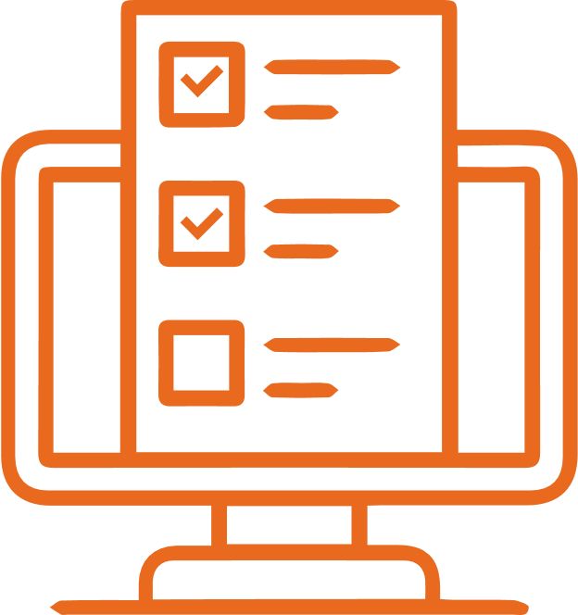

**Step 2:** Complete the questionnaire.

This generates a custom claim form package for you.

* If you are filing a Wellness Benefit claim, this process is completed online during this questionnaire. No claim form is necessary. Simply submit your claim at the end of the questionnaire.



**Step 3:** Download your claim form package, if applicable.

 **Step 4:** Complete the form package, if applicable, or go to Step 5.

Have each form completed by the appropriate party, as outlined in the claim form package.

 **Step 5:** Gather additional documents.

Collect any additional supporting documents, as instructed on the claim form “for you”.

 **Step 6:** Submit.

Using your preferred submission method, submit your completed and signed forms, as well as any supporting documents.

* To submit your claim **online** via a secure upload, visit voya.com/claims and click on Step 2, “Submit Your Forms”.
* To **mail** or **fax** your submission, see the top of your custom claims form package.

Questions about the claim process?

For **Accident, Critical Illness and/or Hospital Confinement Indemnity Insurance claims**,   
call **1-877-236-7564.**

Insurance products are issued by ReliaStar Life Insurance Company (Minneapolis, MN), a member of the Voya® family of companies. Voya Employee Benefits is a division of ReliaStar Life Insurance Company. Product availability and specific provisions may vary by state and employer’s plan.

Valley Regional Healthcare, Inc., Group #0070506-3 Date Prepared: 9/19/2022

©2021 Voya Services Company. All rights reserved. WLT250009329. 1659211

175254-08152021