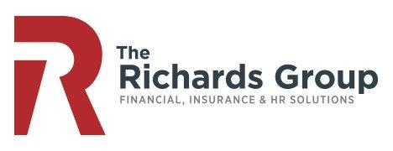

**Benefits Technology & Enrollment Systems**

The Richards Group focus is to provide clients with advanced technologies and electronic solutions that streamline employee benefits processes from start to finish. From strategic partnerships with United Benefit Advisors, eBenefit Marketplace and our own benefits technology experts, we can guide clients to the best enrollment solution for their company. Moving to a new technology platform is one of the most critical decisions you can make, and choosing the right solution takes the right partner. We will work with you to find the system that best fits your goals, budget, and makes your job easier.

**Our In-House Solutions**

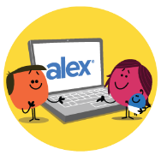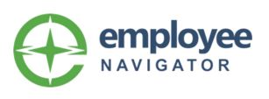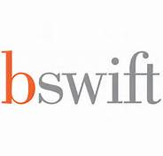

**Paylocity is an award-winning provider of cloud-based HR and payroll software solutions, offering an intuitive, easy-to-use suite that helps businesses automate and streamline HR and payroll processes.** Paylocity delivers the experiences employees want, drawing them into the platform daily — not just when they need to find their W-2.

**Jelly Vision (Alex)** is a one-on-one conversation that helps employees choose and use their benefits. Alex uses simple explanations, playful animations, and behavioral science to engage employees. Alex’s personalized recommendations help employees make smarter benefit decisions and provides printable benefit summary pages that employees can refer back to.

**Ask Emma** is an interactive decision support tool within **bswift** that recognizes employees as individuals. She asks a few simple questions, then suggests plan options based on employees’ unique responses, integrated claims data and national data. Emma translates insurance jargon, provides cost comparisons, models health scenarios and more.D

**Employee Navigator’s modern and easy to use software platform that saves time, minimizes errors, and automates processes, will restore some precious time back into your day.** Employee Navigator is perfect for smaller to mid-size groups.

**bswift’s state of the art cloud-based technology that makes online enrollment simple and speedy for your employees**–and easier for you and your team to manage. It includes personalized, built-in decision support with ongoing engagement and communication, including custom videos and text messages.

**Decision Support Tools:**