Sun Life
Sun Life’s Accident & Wellness Videos : https://www.brainshark.com/1/player/en/sunlife?fb=0&r3f1=&custom=accidentwellness
Short Term Disability
https://www.brainshark.com/1/player/en/sunlife?fb=0&r3f1=&custom=short-term-disability


Long Term Disability
https://www.brainshark.com/1/player/en/sunlife?fb=0&r3f1=&custom=long-term-disability


Critical Illness w/Wellness Benefits
https://www.brainshark.com/1/player/en/sunlife?fb=0&r3f1=&custom=critical-illness-wellness



Accident Insurance
https://www.brainshark.com/1/player/sunlife?fb=0&r3f1=d2e896c5c9c49c8ede87f3859cccc4d2ce8386ae86c2dec5c7d1998ae3919fdad8cb8e8296ee8ed8dfd2c0c89f82ee81d8d8db89c49fced5b19ed0d9c0ce838ee1c1e798cdc48b8683d5df&custom=accident



Life Insurance
https://www.brainshark.com/1/player/en/sunlife?fb=0&r3f1=&custom=life_insurance
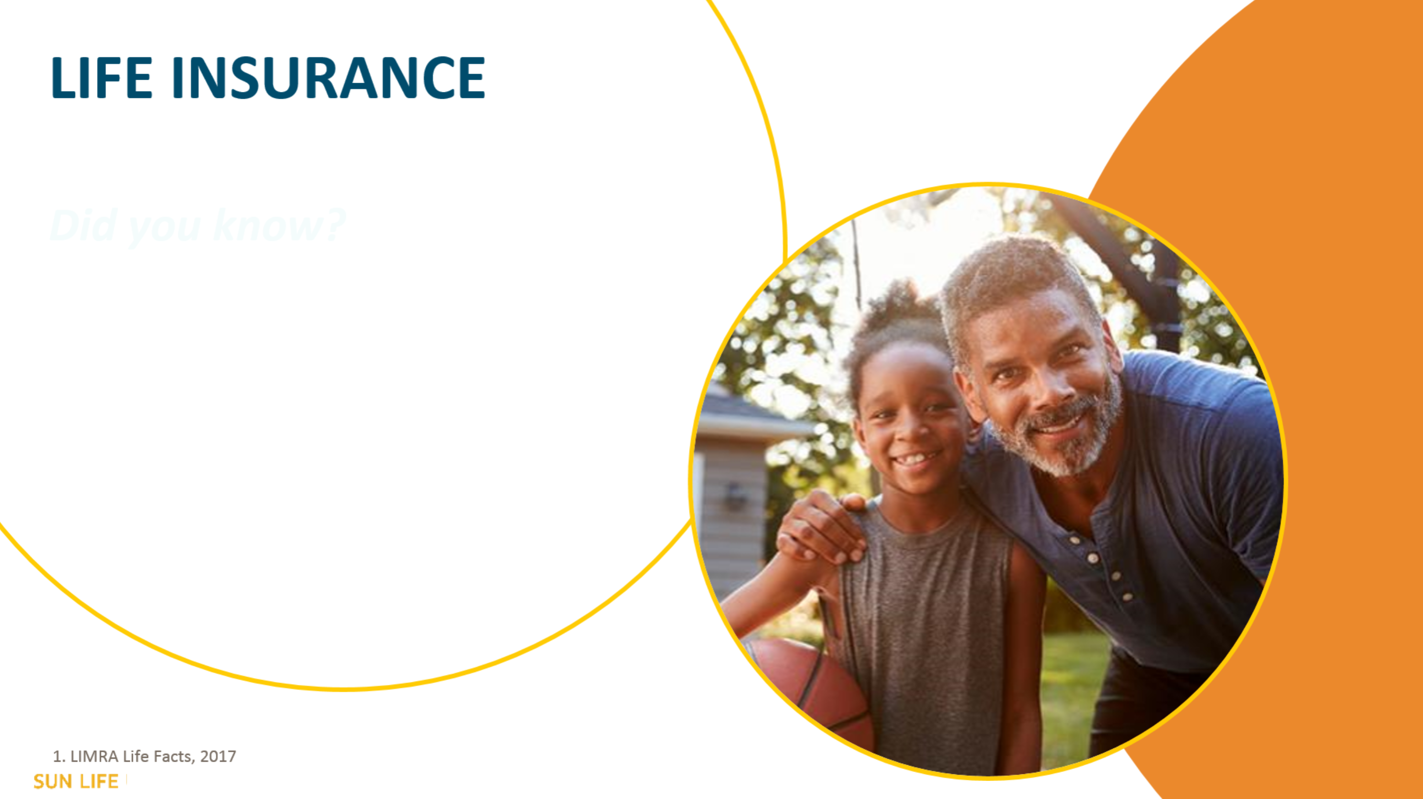

How to submit EOI - online
https://www.brainshark.com/sunlife/Submit-EOI-Member-Online

How to submit EOI - paper
https://www.brainshark.com/sunlife/Submit-EOI-Member

Sun Life is offering benefit counselors via telephone, Q&A sessions, and will conduct virtual group meetings & 1:1 sessions.

Rx Benefits
Will continue to support our Client needs by:
- Providing Materials (Electronically or by Mail)
- Providing Giveaways and / or Raffle Items
- *Attending Virtual Benefit Fairs / Open Enrollment Meetings.
No videos have been created yet

Invest EAP
We do have some pre-recorded videos and EAP orientations for use in a pinch.
Have not sent videos yet (will send videos by 9/15)

HPI
https://www.brainshark.com/1/player/healthplansinc?fb=0&r3f1=&custom=neah-oe

https://www.youtube.com/watch?time_continue=4&v=lpEzqf_ej1E&feature=emb_logo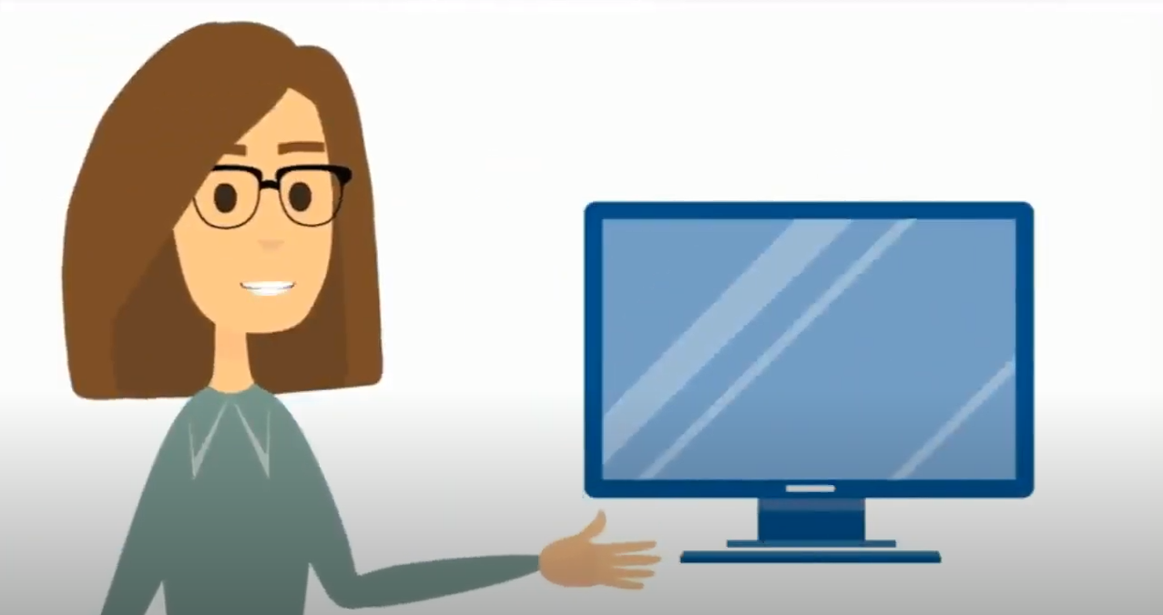
ID Watchdog
https://vimeopro.com/user60538745/everywhere-video

https://vimeopro.com/user60538745/your-guide-to-identity-theft
https://vimeo.com/460244339

Legal Access
Enrollment Strategy can be found here:
"L:\6-Marketing_Communications\10-Videos\Legal_Access_Plans_20200724.pdf"
Jim Beideck indicated that they need at least a couple of weeks lead time if groups would like customized materials for webinars (jim_beideck@legalaccessplans.com)

Legal Shield & ID Shield
Here are two videos for IDShield and LegalShield:
LegalShield Membership Video B2B:
https://ls-info.com/d/JSZsGy
IDShield Membership Video B2B :
https://ls-info.com/d/FySqvq

Health Advocate Core & EAP
http://www.healthadvocate.com/video/HA-M-2007022-EAP.html
http://www.healthadvocate.com/video/HA-M-2007022-Advocacy.html

Jellyvision
Marketing Campaigns saved here: L:\8-Technology\4-ALEX_Jellyvision\Marketing_OE_Communications\2020

Nationwide Pet Insurance
Open Enrollment resources here: https://pages.email.petinsurance.com/page.aspx?QS=773ed3059447707dc97a5d1a1dfd876dc8c3f9b7e8f3fb25a0debf846d455912



Delta Dental
\\richardsins.com\Network\Benefits\6-Marketing_Communications\10-Videos\2021DentalOverview.mp4
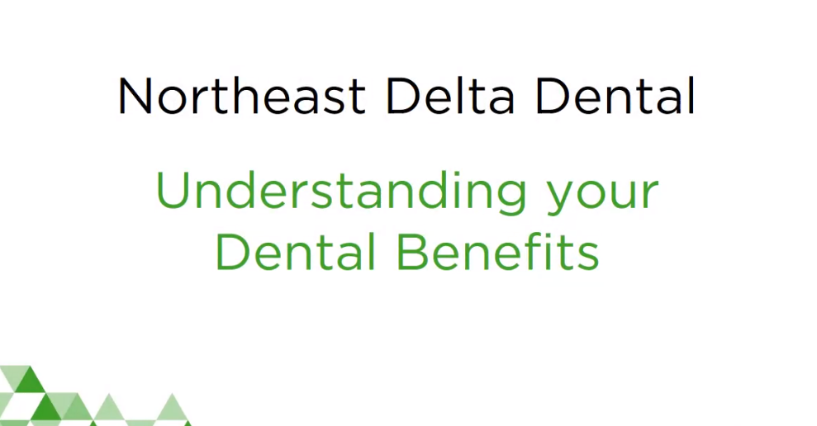

\\richardsins.com\Network\Benefits\6-Marketing_Communications\10-Videos\2021NextGen PPO + Premier OE .mp4
\\richardsins.com\Network\Benefits\6-Marketing_Communications\10-Videos\2021NextGen PPO OE .mp4
\\richardsins.com\Network\Benefits\6-Marketing_Communications\10-Videos\2021OETemplatewithDoubleUpMax.mp4

RSLI
Life: https://vimeo.com/116998792/d93afb578e
Disability: https://vimeo.com/230614636/f194f07502
AD&D: https://vimeo.com/230614804/d5479000a1
VCI: https://vimeo.com/293556374/ad46b04707
Accident: https://vimeo.com/116998793/af918250b6
MVP
Video for Find a Doctor
https://www.youtube.com/watch?v=oS016QvCU-4
Video for how to Register for your online MVP Account
https://www.youtube.com/watch?v=Sl2H5Y_lLLg
Cigna
We have both pre and post enrollment videos available for our U500 markets; distribution to our O500 markets is most likely feasible but I would follow up with your O500 Cigna Engagement Consultant.
- Virtual Care
- Health Care 101
- HRA
- HSA
- EAP
- Condition Management
- Stress Management
- Weight Management
- Tobacco Cessation
- Pharmacy Resources
- Dental PPO
Pre-Enrollment
Post-Enrollment
VSP
https://www.youtube.com/user/vspvisioncare/videos
newer:
https://www.youtube.com/watch?v=Q-ykaAM5ako
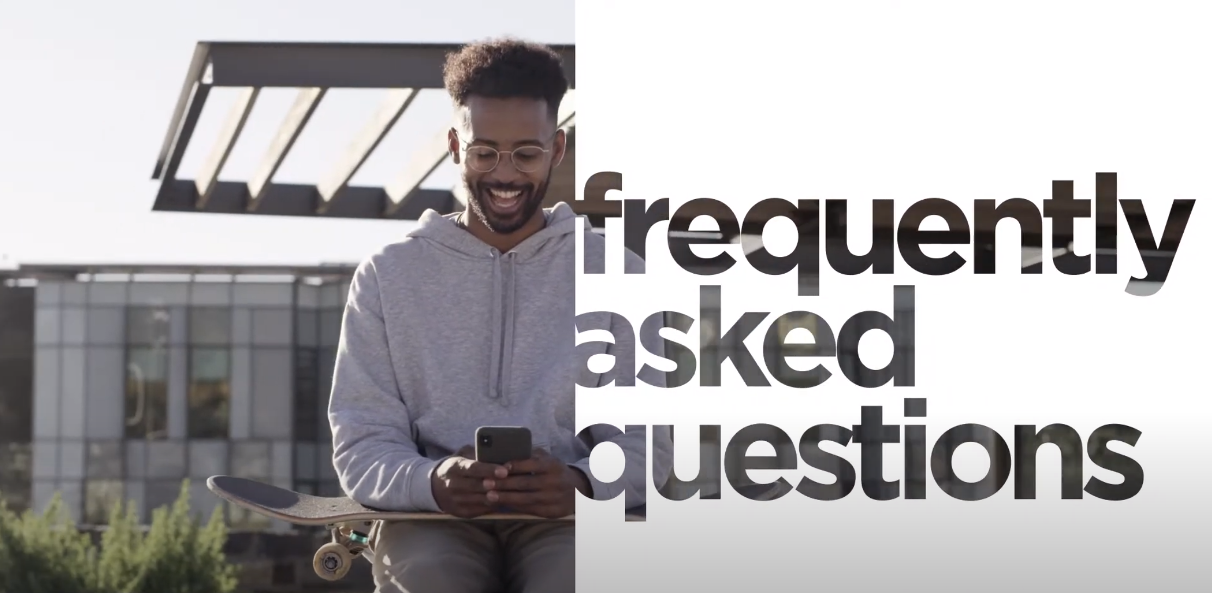
https://www.youtube.com/watch?v=_hKqZ-H8rdk
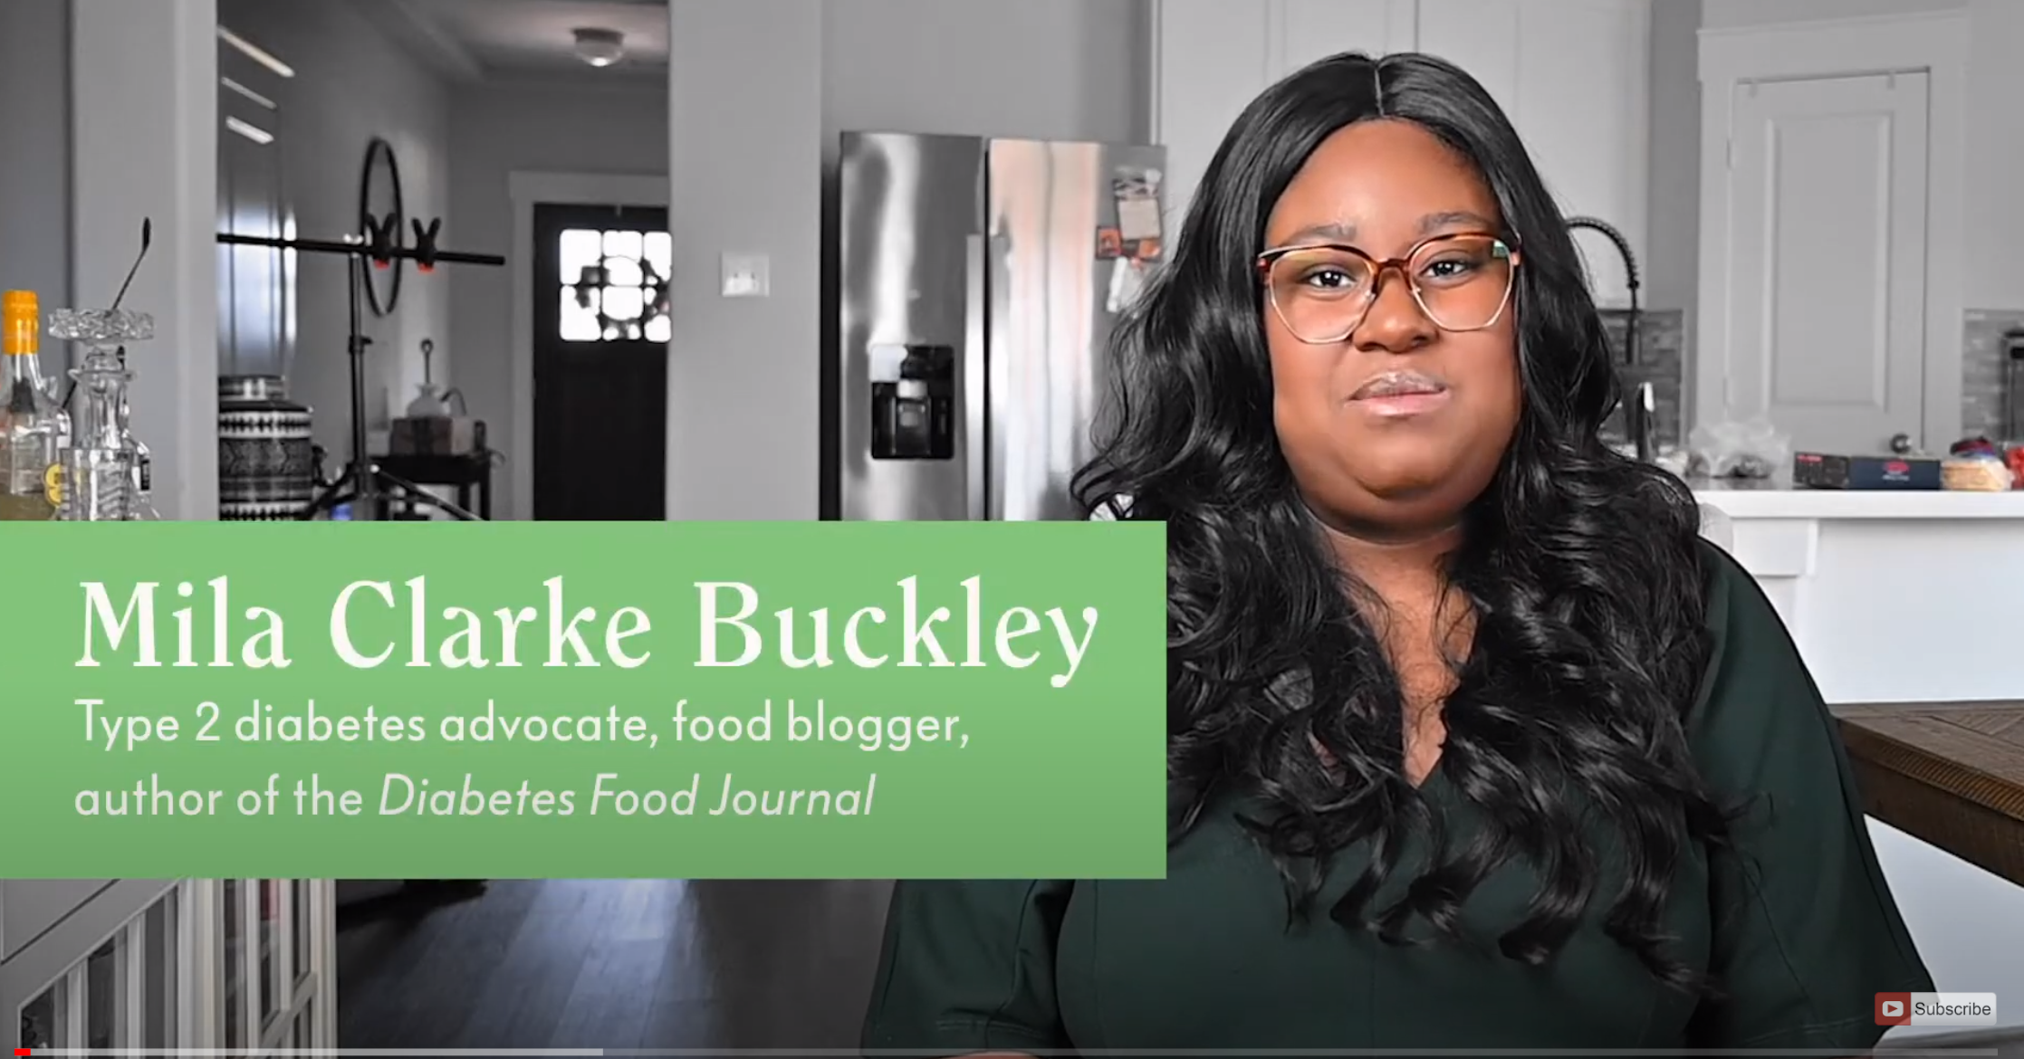
https://www.youtube.com/watch?v=TUGHuHFuT2w

Benefit Strategies
https://www.benstrat.com/open-enrollment/
https://www.benstrat.com/resources-videos/
Health Equity
https://healthequity.com/oetoolkit?utm_source=broker&utm_medium=email-sfmc&utm_campaign=leadsnurture&utm_content=20200610-e11-1193565
