AUGUST 2023
Sunday | Monday | Tuesday | Wednesday | Thursday | Friday | Saturday
    August is Summer Sun Safety Month   |  |   1  Executive Management Meeting @ 9am | 2  National Ice Cream Sandwich Day  Join Shauna in the kitchen at 10am for a sweet treat!   | 3    Samantha B’s 3 Year Work Anniversary  New Employee Meeting with Executive Staff @ 9:30am | 4 | 5
6  Jane’s 6 Year Work  Anniversary  National Farmers Market Week   | 7  Allison’s 4 Year Work Anniversary   | 8  Supply Order   | 9 | 10  $Pay Day$   | 11 | 12
13 | 14 | 15  Samantha B’s Birthday  Amber’s Birthday  National Relaxation Day | 16  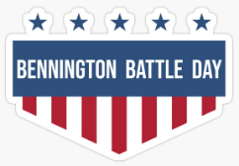  VSHA Closed | 17  National Thrift Shop Day    Managers Meeting @ 9am | 18 | 19
20  World Mosquito Day  Kill them All! Prevent the spread of disease.  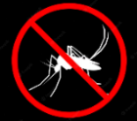 | 21 | 22    Supply Order | 23 | 24  VSHA Picnic  *Details Forthcoming    $Pay Day$ | 25  Dave’s Birthday   | 26  Jen C’s Birthday  
27 | 28  National Thoughtful Day   | 29  Jason B’s Birthday  Barb’s Birthday  Kathleen’s 35 Year Work Anniversary  Check Run | 30  Olga’s Birthday    National Grief Awareness Day | 31  Eat Outside Day   | Did you know that up to 80% of the sun’s harmful UV rays can penetrate your skin, even on cloudy days!  It’s a necessity to apply sunscreen to exposed skin daily with an SPF 30 or higher and broad-spectrum UVA/UVB protection.

