**How to access 2021 Open Enrollment Event in ADP**

1. Login in to ADP:

<https://workforcenow.adp.com/workforcenow/login.html>

1. Enter your Log In information

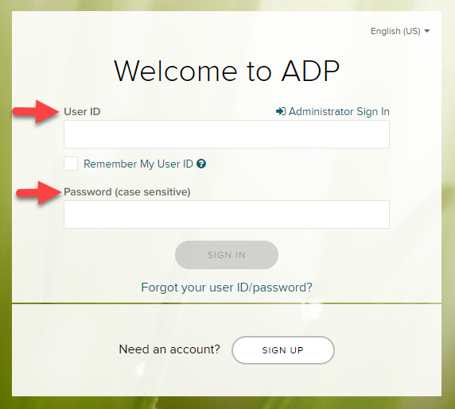

1. Once logged in to ADP, the 2021 Open Enrollment window will greet you. To begin reviewing/making edits to your benefits, click on the blue “Start This Enrollment” button

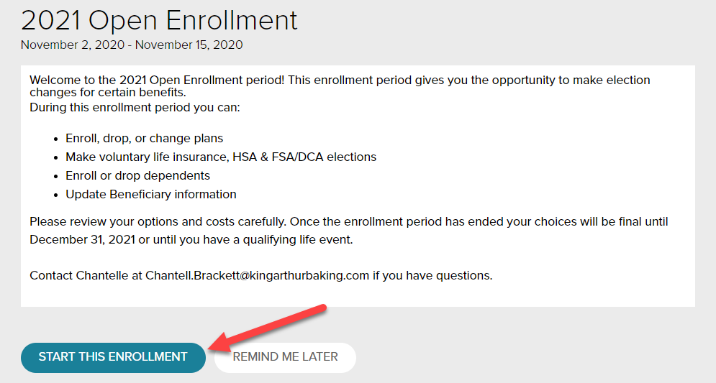

1. The system will give you the option to review each of the benefits you are eligible for or currently enrolled in for the 2020 plan year. The event will remain open for the duration of the Open Enrollment period (November 2nd through 15th).

You will have the opportunity to make any changes you’d like to your elections during these two weeks. The Open Enrollment event will close at 11:59pm on November 15th, and no other elections will be allowed after that point. Once completed, click the submit button.