Manually Logging Your Minutes for Money to Move
To manually log your minutes of activity for Money to Move, log into your account at www.bewellvermont.org. Be sure to register for the current challenge (by clicking on the “Register Now” button) if you have not already. To see all the current challenge options click on “Money to Move” in the top navigation bar.
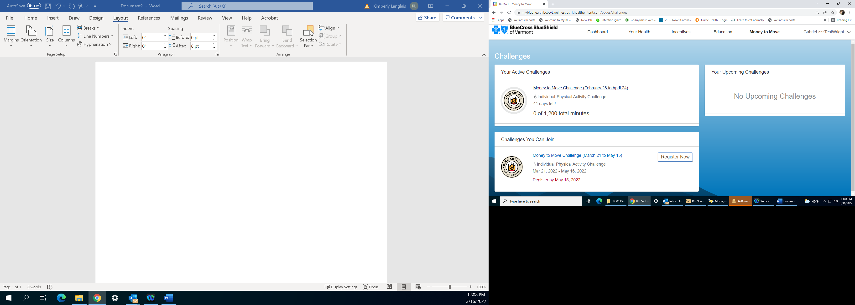

To get to the physical activity tracker to log your minutes click “Your Health” in the top navigation bar and click on “Health Trackers” in the left navigation bar. Select “Physical Activity” to get to the tracker that is connected to Money to Move.
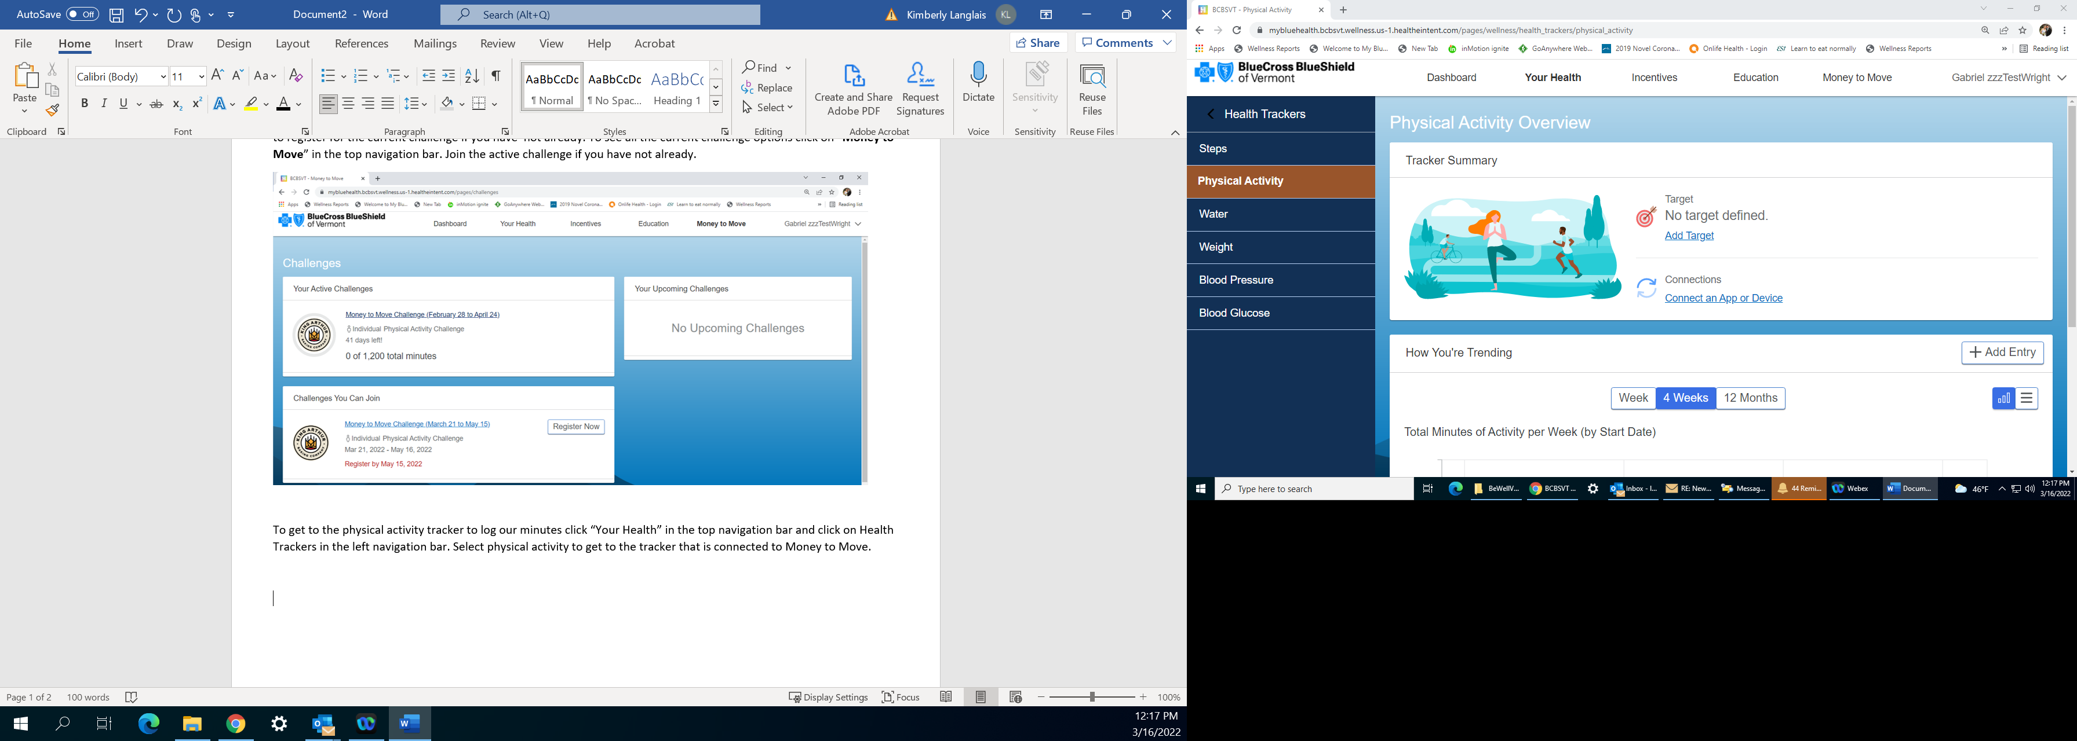

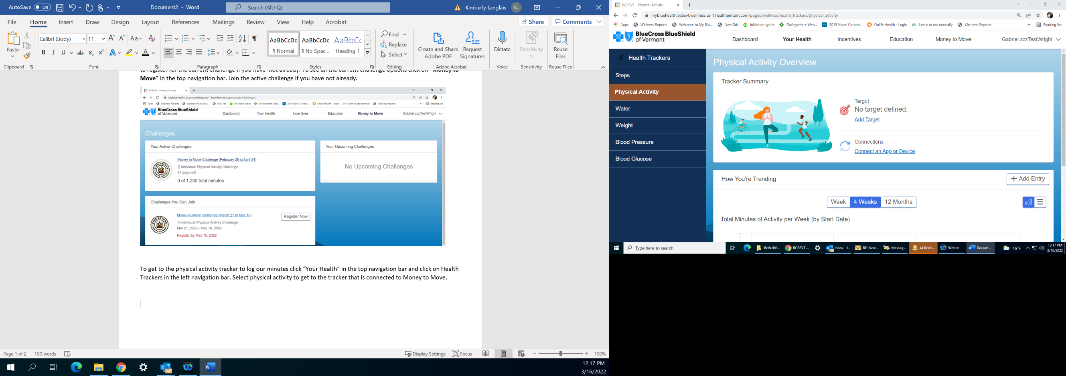
Click on the “Add Entry” button on the right side of the screen
to put in your minutes.

The Add Entry box will ask you for the date you completed your minutes of exercise, the type of activity you did and how many minutes you were active. The very first time you use the tool it will ask you for your weight so that the tool will be able to approximate your calorie burn for future workouts. If you cannot find the exact type of activity you participated in, please select the one you feel is closest to what you did. Hit “Save” if you are putting in a single entry. If you are back logging multiple entries hit “Save & Add Another”.
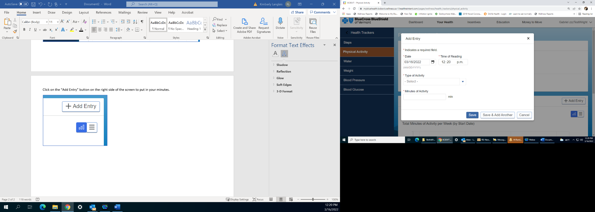

Note that if you do choose to use the “Save & Add Another” feature the Add Entry pop up will turn red for type of activity and minutes of activity. This is so you can update the next entry. It does not indicate that there was an error with the first entry you made.

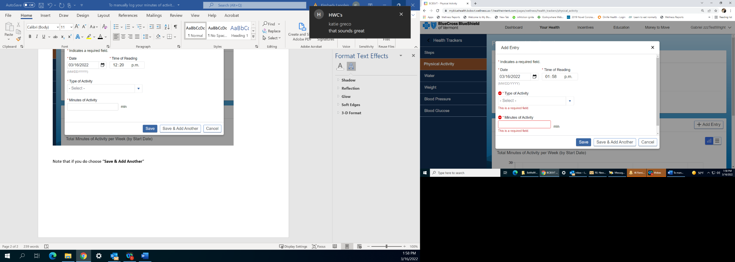

Syncing a Device to Log Your Minutes for Money to Move
1. Select Health Trackers from the menu bar on the left.
2. Select Physical Activity from the menu bar on the left.
3. Select Connect an App.
4. Choose your app from the list of available connections. Select Connect.
5. Enter your health tracker’s account information, then follow its instructions to connect.**

*Apple device and Apple Health connections must be completed through the Healthy Path app installed on an iPhone. Samsung Health connections must be made through the Healthy Path app installed on an Android phone. See the KAB Wellness FAQ documents for additional instructions if needed.

**Please allow all permission settings when connecting your device. Data from your connected app will usually display within 15 minutes. Allow up to 24 hours before contacting support. Do not disconnect and reconnect your device if data is not syncing, as your data is not recoverable while disconnected.

