After you log into the system, click on Eligible Activities in the middle as shown below.

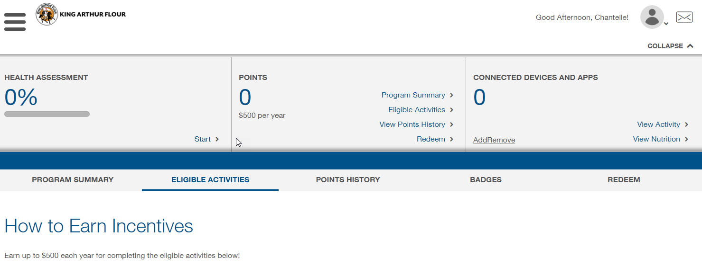

Scroll to the bottom of that page and click on Join the Challenge.

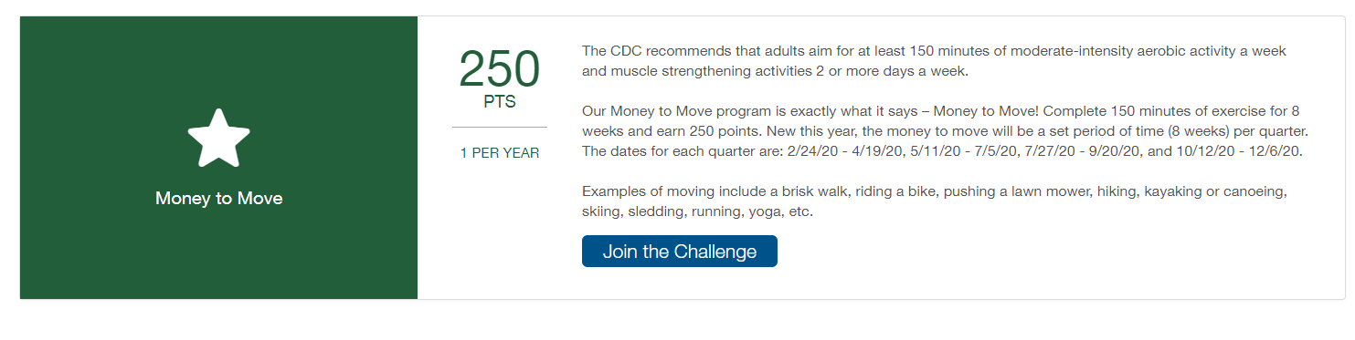

Click on Join Challenge.

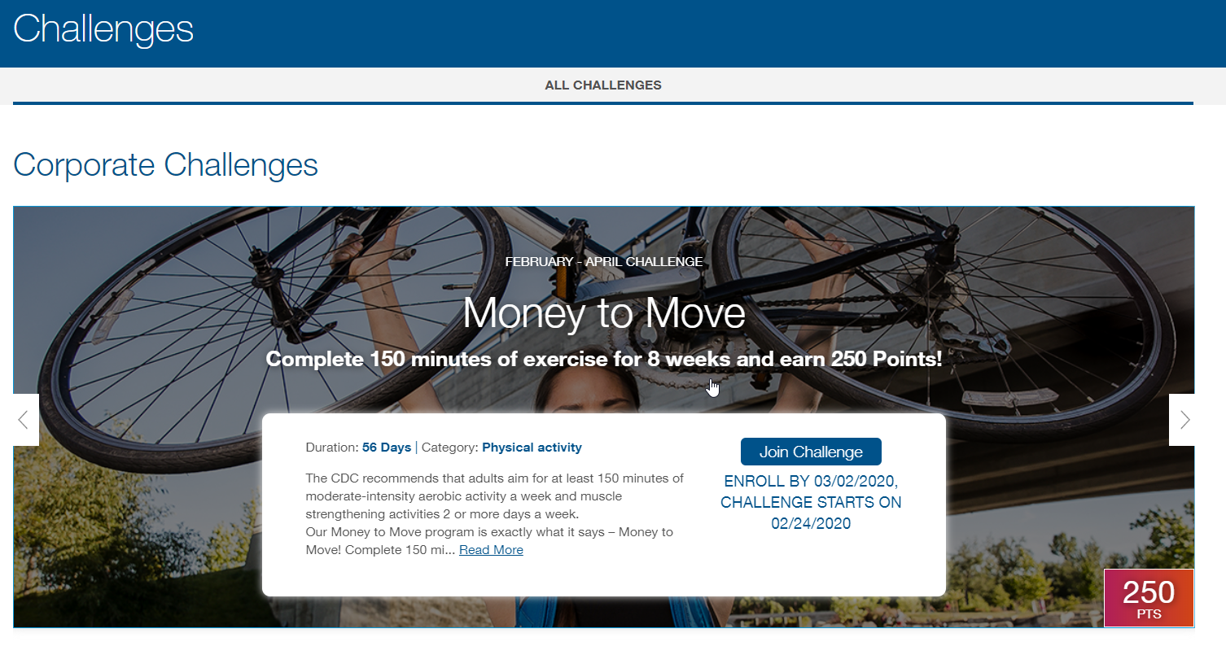

It will then show your status for the challenge as In Progress.

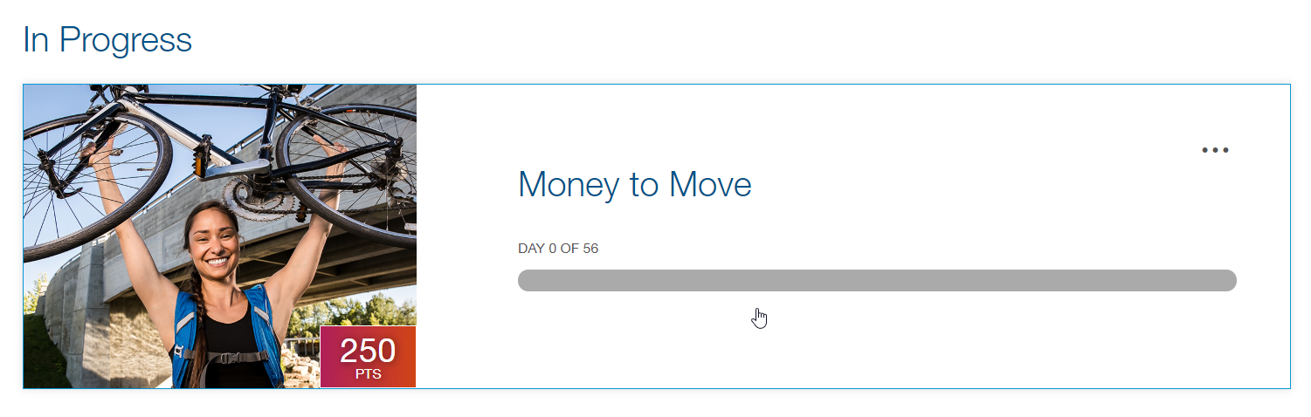

Below is how you will track/log your activity.

