Subject Line: Sip Smart Week 4 – Celebrate Your Progress
Attachments:
- Week 4 Guide
- Tracker
Body:
Sip Smart Challenge, week 4
Enter Dates
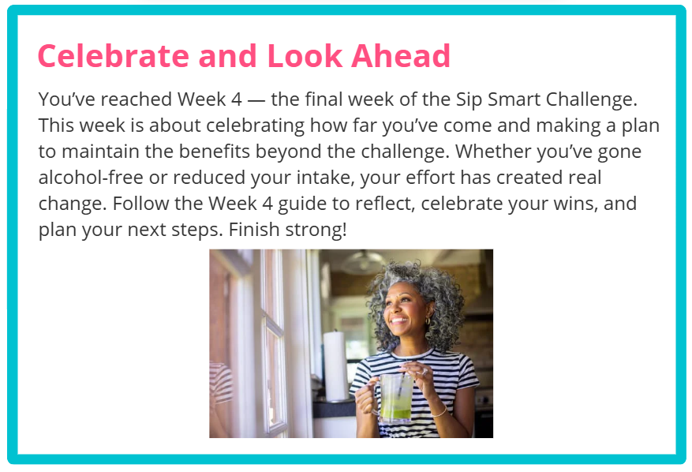
Participants who submit their challenge tracker to Human Resources by
[Insert Date] will be entered into a prize raffle for [Insert Raffle Prize].

