Subject Line: Sip Smart Week 3 – Confidence in Social Settings
Attachments:
- Week 3 Guide
- Tracker

Body:
Sip Smart Challenge, week 3
Enter Dates
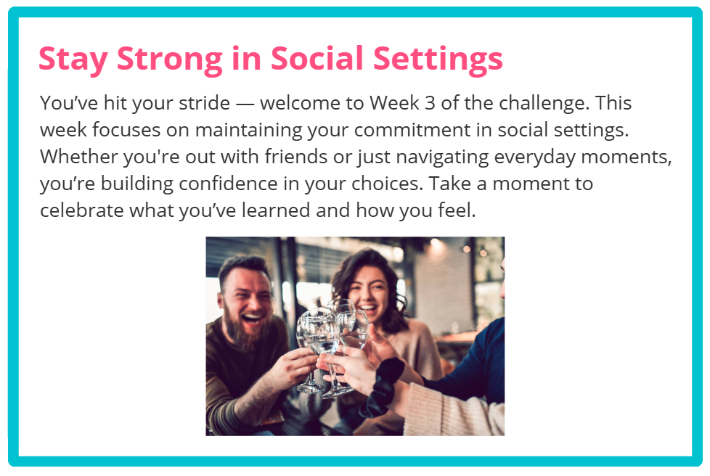
Participants who submit their challenge tracker to Human Resources by
[Insert Date] will be entered into a prize raffle for [Insert Raffle Prize].

