Subject Line: Sip Smart Challenge Begins – Let’s Get Started
Attachments:
- Week 1 Guide
- Tracker
Body:
Sip Smart Challenge, week 1
Enter Dates
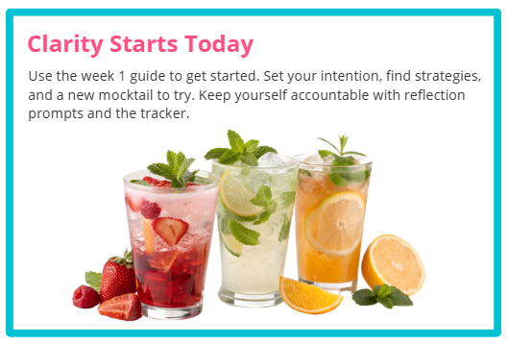
Participants who submit their challenge tracker to Human Resources by
[Insert Date] will be entered into a prize raffle for [Insert Raffle Prize].

