Subject Line: You Did It – Sip Smart Challenge Complete!
Attachments:
- Tracker
Body:
Sip Smart Challenge
Enter Dates
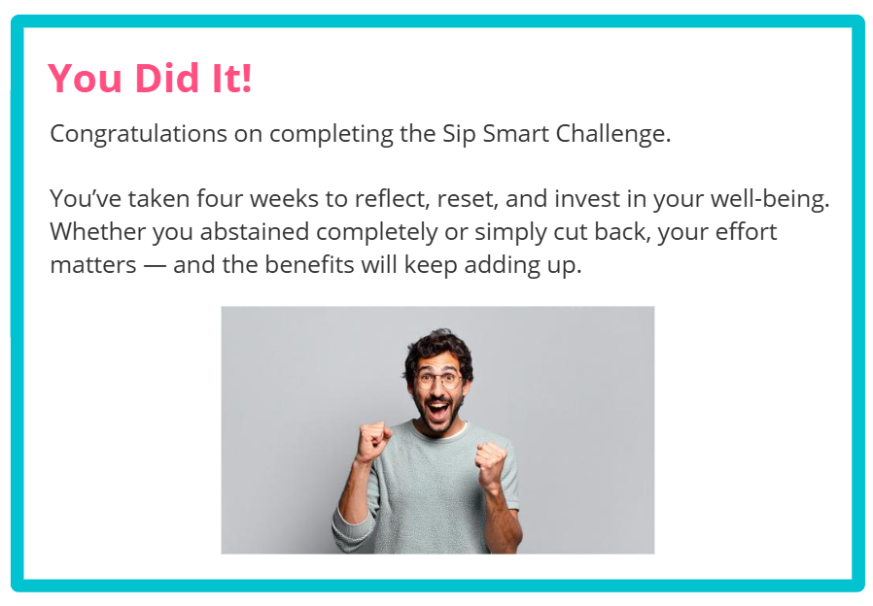
Participants have until [Insert Date] to submit their completed challenge tracker to Human Resources to be entered into a prize raffle for [Insert Raffle Prize].

