Subject Line: Ready to reclaim your time? Join the Sip Smart Challenge!

Body:
Sip Smart Challenge
Enter Dates
If applicable: Sign up here (insert link)
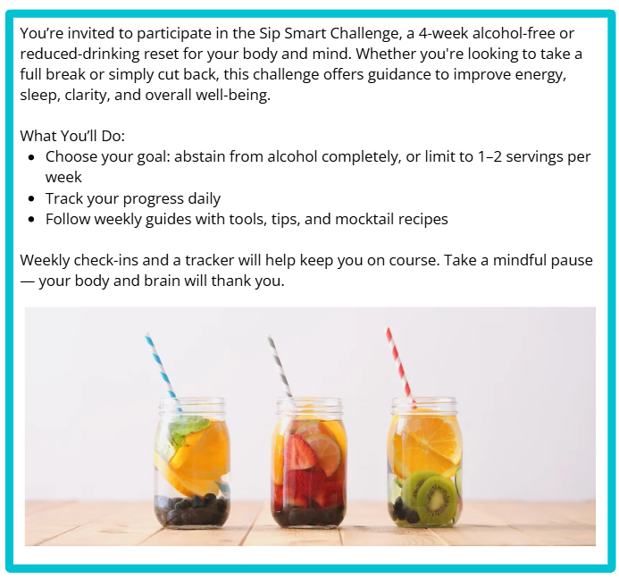
Participants who submit their challenge tracker to Human Resources by
[Insert Date] will be entered into a prize raffle for [Insert Raffle Prize].

