Subject Line: Week 1 – Get Organized & Build Your Safety Net

Attachments:
- Week 1 Guide
- Tracker
Body:
Monday Night Finance – Week 1
Enter Dates
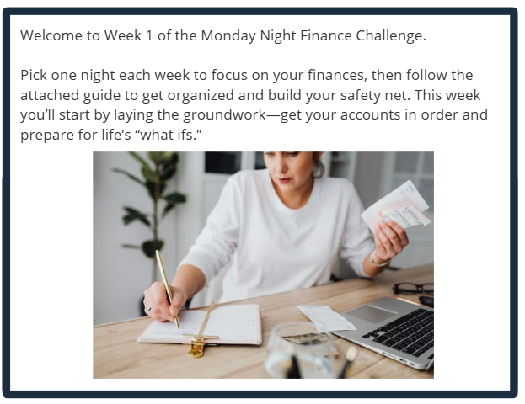
Participants who submit their challenge tracker to Human Resources by
[Insert Date] will be entered into a prize raffle for [Insert Raffle Prize].

