Subject Line: Join the 4-Week “Monday Night Finance” Challenge

Body:
Monday Night Finance
Enter Dates
If applicable: Sign up here (insert link)
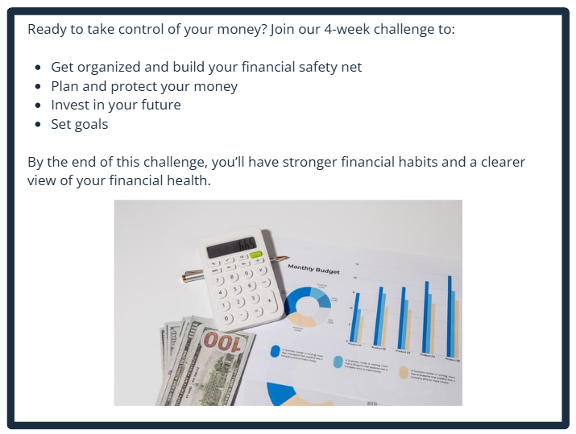
Participants who submit their challenge tracker to Human Resources by
[Insert Date] will be entered into a prize raffle for [Insert Raffle Prize].

