Subject Line: Week 3 – Let’s Read Together
Attachments:
- Week 3 Guide
- Tracker

Body:
Bookworm Blitz – Week 3
Enter Dates
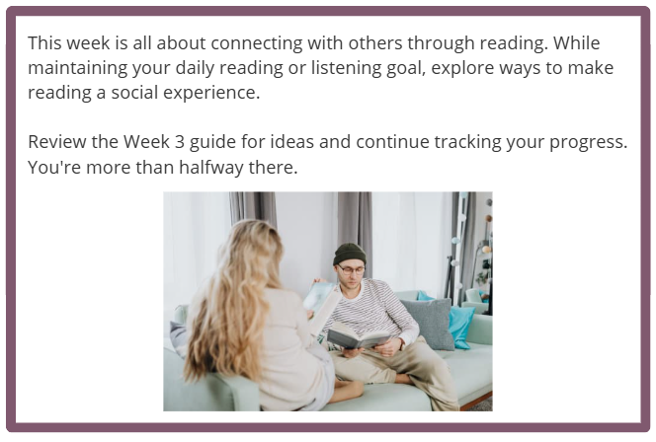
Participants who submit their challenge tracker to Human Resources by
[Insert Date] will be entered into a prize raffle for [Insert Raffle Prize].

