Subject Line: Week 2 – Reflect and Write

Attachments:
- Week 2 Guide
- Tracker

Body:
Bookworm Blitz – Week 2
Enter Dates
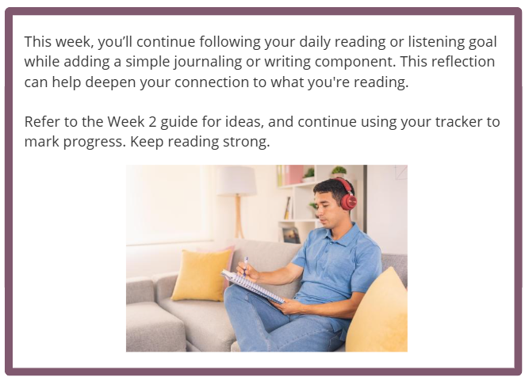
Participants who submit their challenge tracker to Human Resources by
[Insert Date] will be entered into a prize raffle for [Insert Raffle Prize].

