Subject Line: Challenge Complete – You Did It!
Attachments:
- Tracker
Body:
Bookworm Blitz
Enter Dates
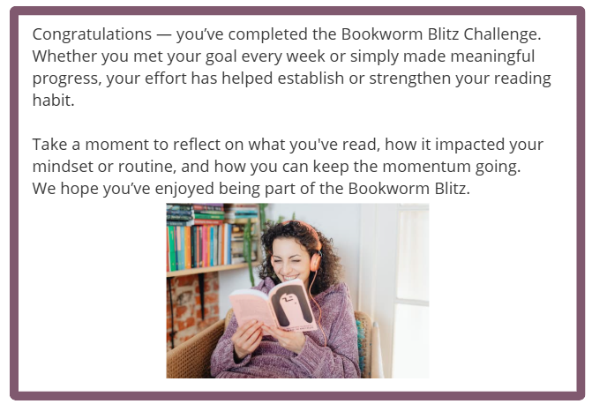
Participants have until [Insert Date] to submit their completed challenge tracker to Human Resources to be entered into a prize raffle for [Insert Raffle Prize].

