Subject Line: Ready to Read More? Join the Bookworm Blitz Challenge

Body:
Bookworm Blitz
Enter Dates
If applicable: Sign up here (insert link)
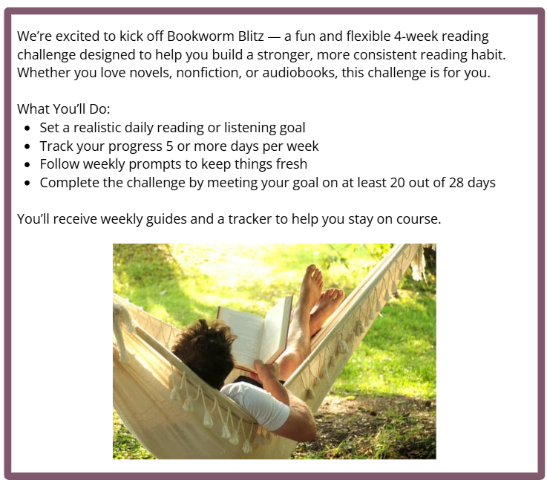
Participants who submit their challenge tracker to Human Resources by
[Insert Date] will be entered into a prize raffle for [Insert Raffle Prize].

