Subject Line: Digital Detox – Find Joy Offline
Attachments:
- Week 4 Guide
- Challenge Tracker

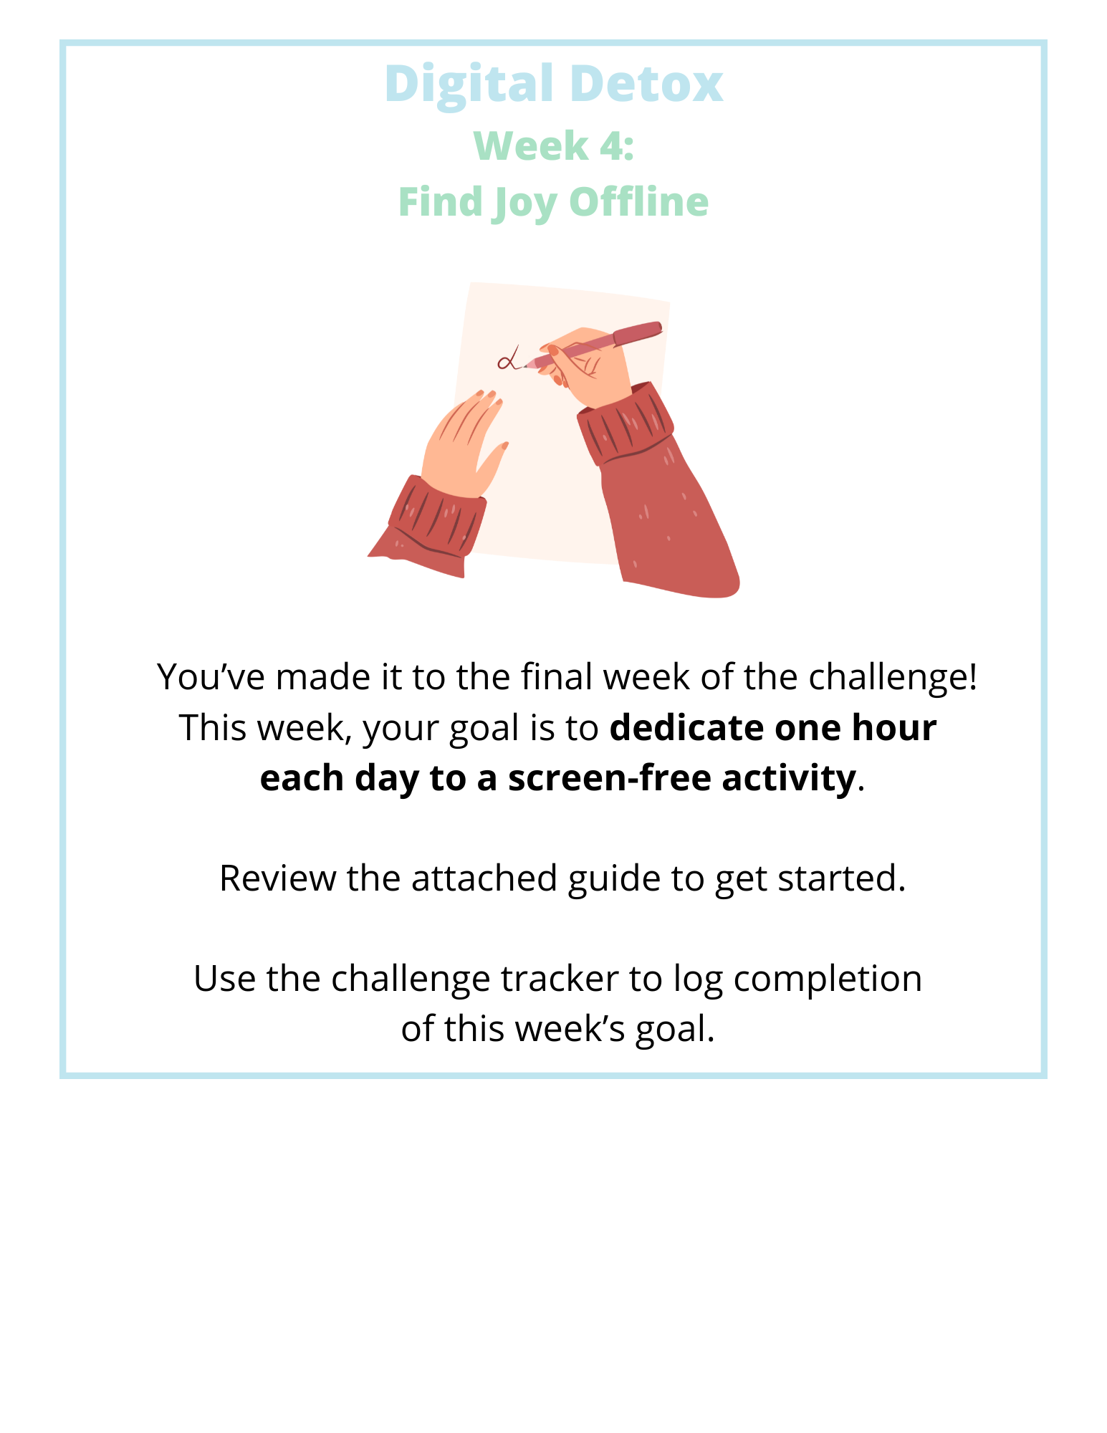
Submit your completed Challenge Tracker to Human Resources by [Insert Date] to be entered into a prize raffle for [Insert Raffle Prize].

