Subject Line: Digital Detox – Break the Boredom Scroll
Attachments:
- Week 2 Guide
- Challenge Tracker

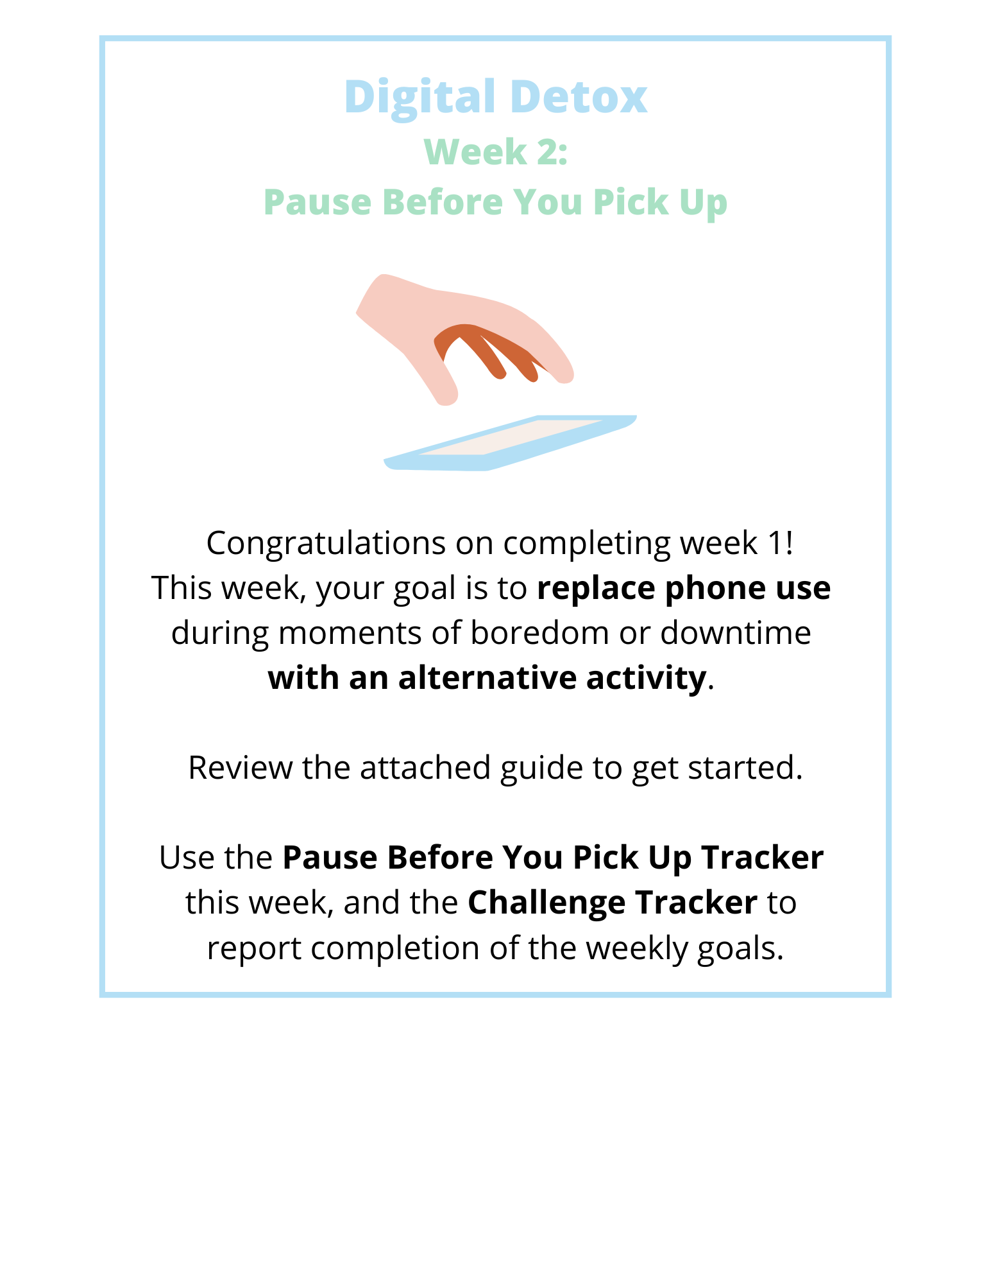
Submit your completed Challenge Tracker to Human Resources by [Insert Date] to be entered into a prize raffle for [Insert Raffle Prize].

