Subject Line: Ready to reclaim your time? Join the Digital Detox Challenge!
Digital Detox
Enter Dates
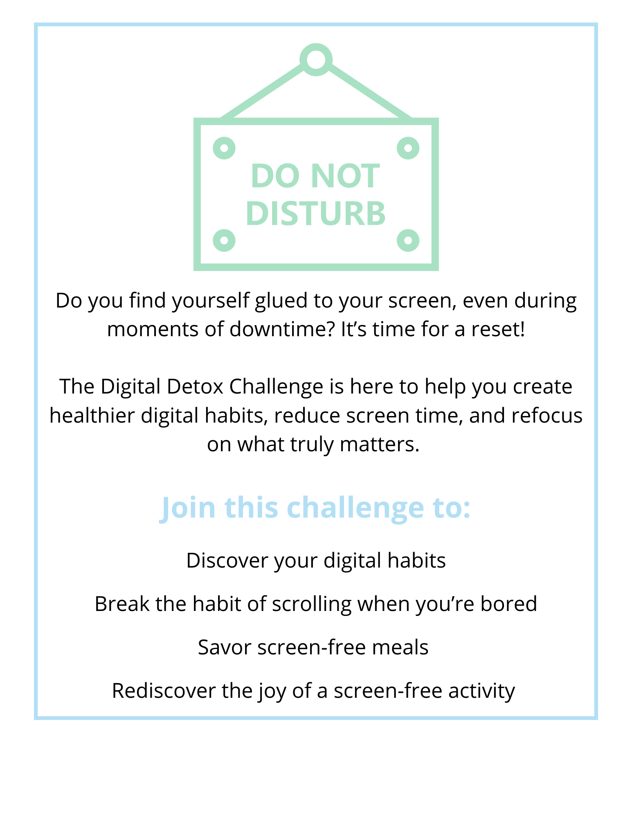
Participants who submit their challenge tracker to Human Resources by
[Insert Date] will be entered into a prize raffle for [Insert Raffle Prize].

