Subject Line: Brain Boost Challenge – Week 4
Attachments:
- Week 4 Guide
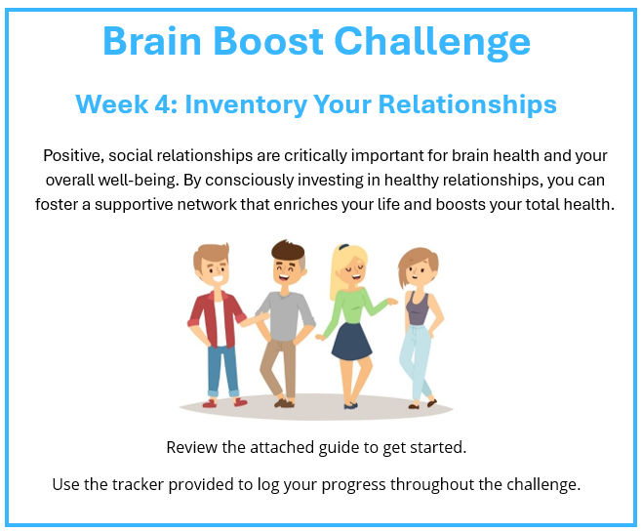
- Challenge Tracker
Submit your completed challenge tracker to Human Resources by

[Insert Date] to be entered into a prize raffle for [Insert Raffle Prize].

