Subject Line: Mission Nutrition – Week 4
Attachments:
- Week 4 Guide
- Challenge Tracker
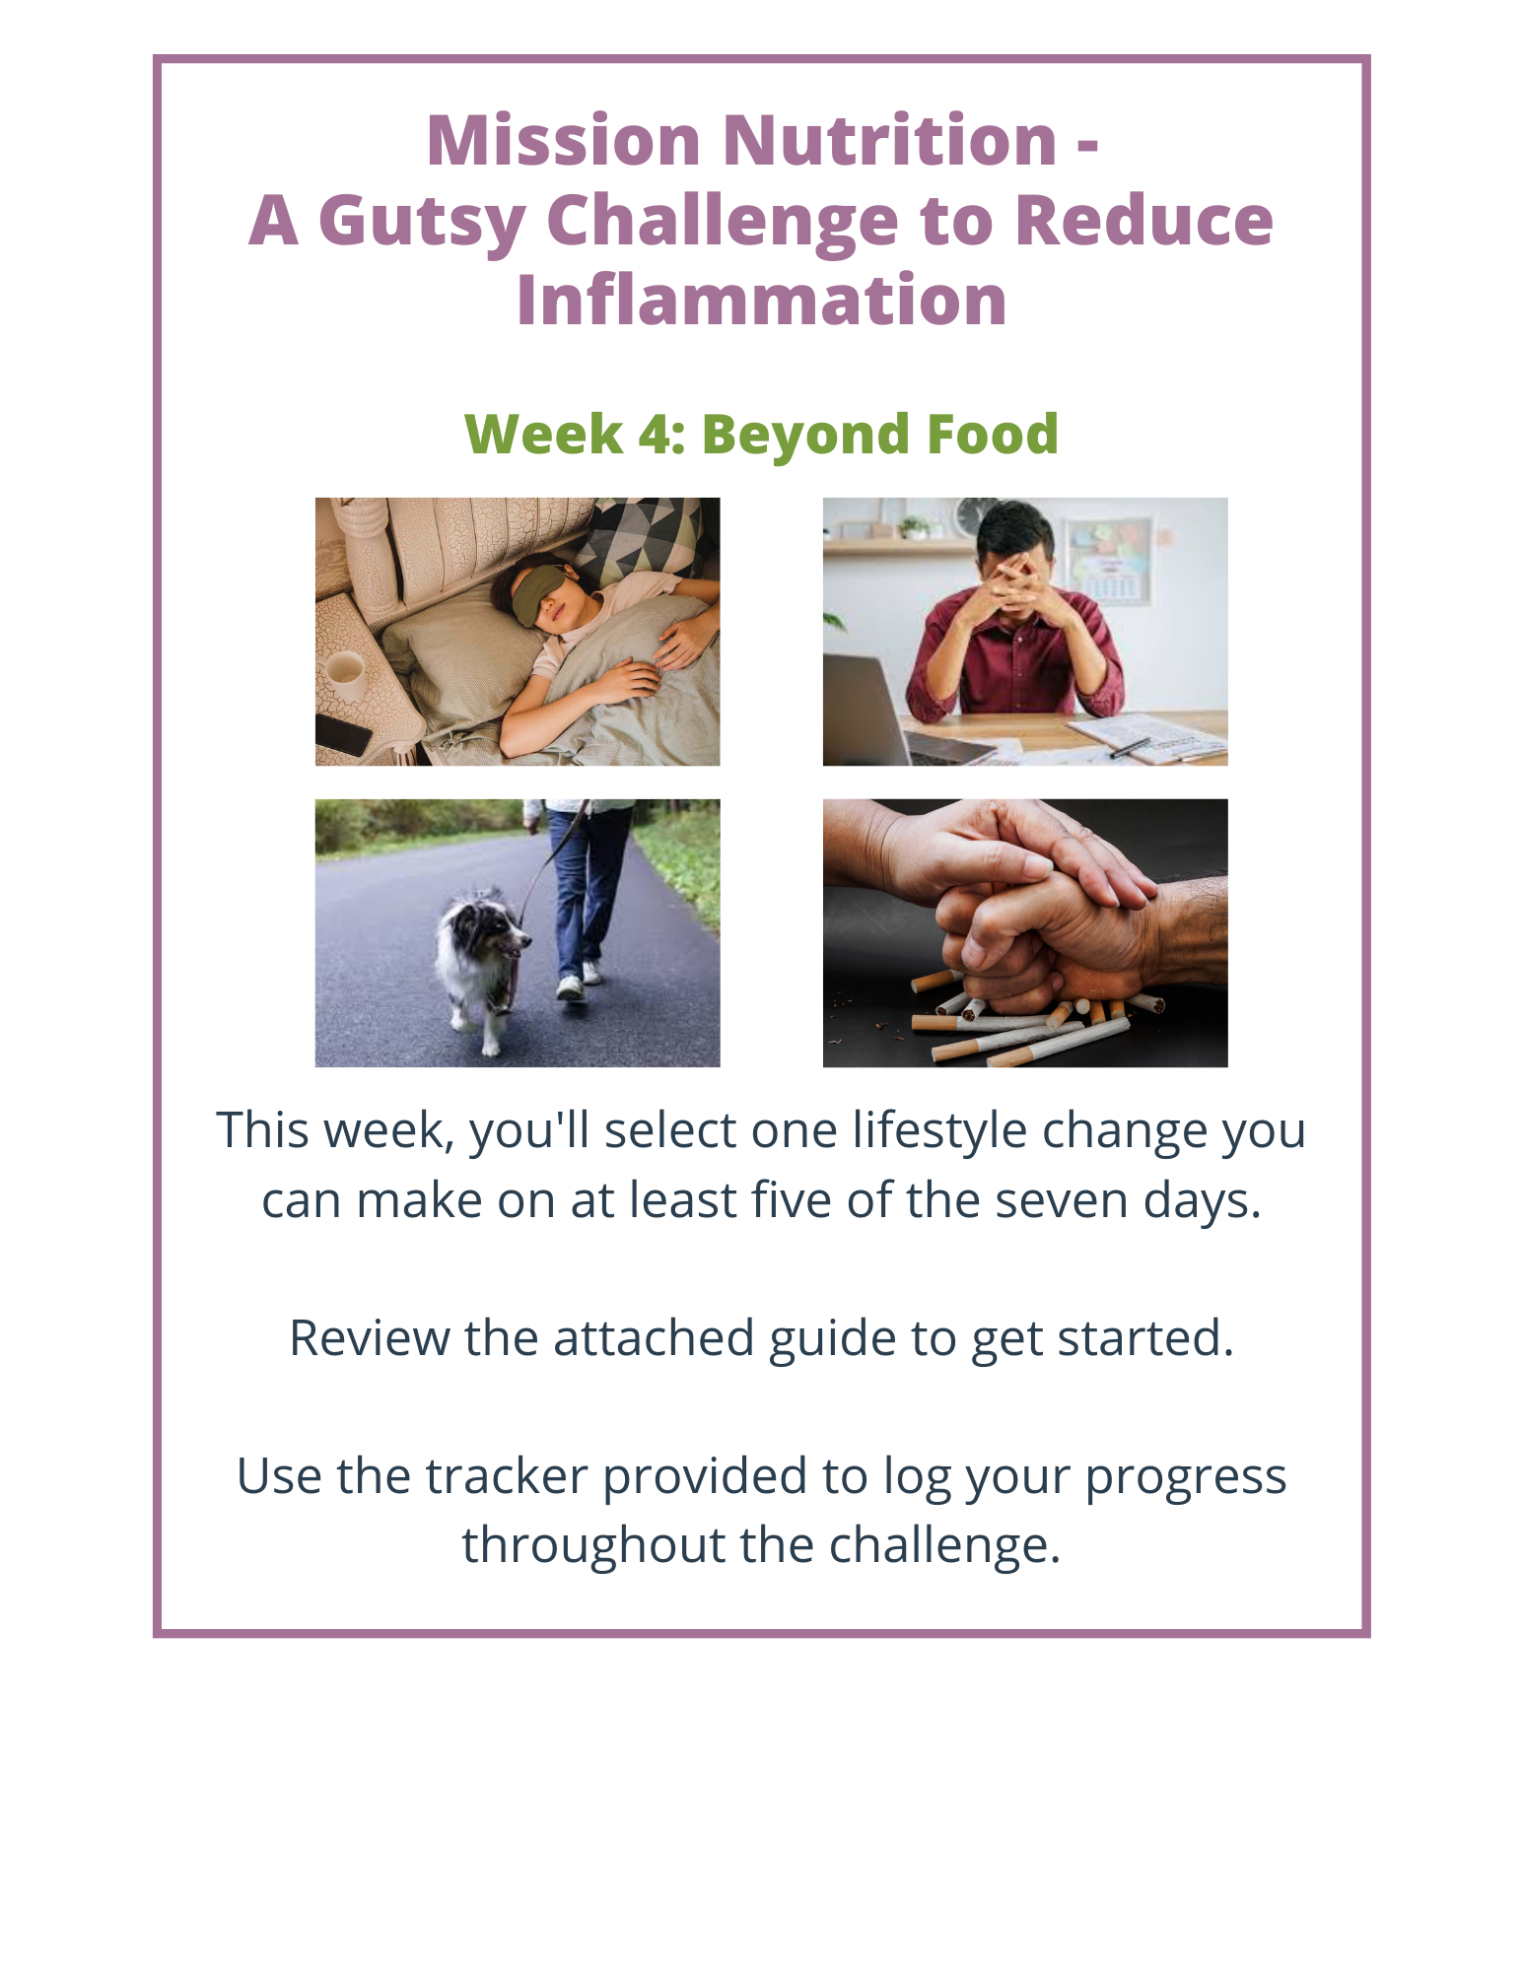
Submit your completed challenge tracker to Human Resources by

[Insert Date] to be entered into a prize raffle for [Insert Raffle Prize].

