Subject Line: Breaking Free with Boundaries – Week 4
Attachments:
- Week 4 Guide
- Challenge Tracker
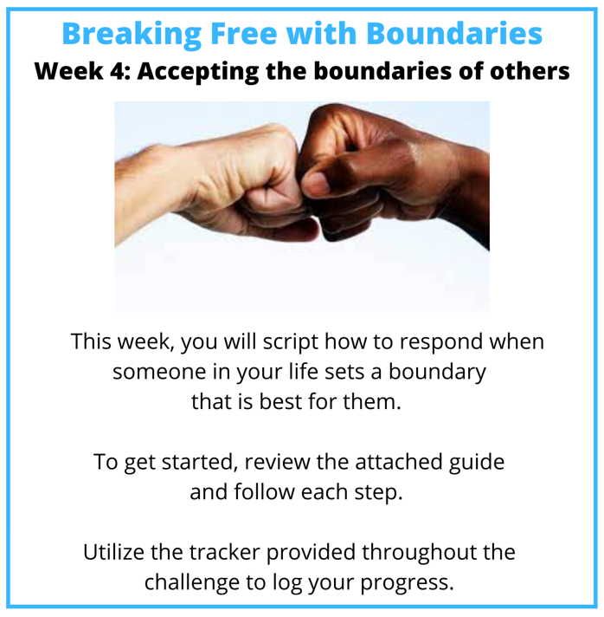
Submit your completed challenge tracker to Human Resources by [Insert Date] to be entered into a prize raffle for [Insert Raffle Prize].


