Subject Line: Breaking Free with Boundaries – Join the Challenge!
Breaking Free with Boundaries
Enter Dates
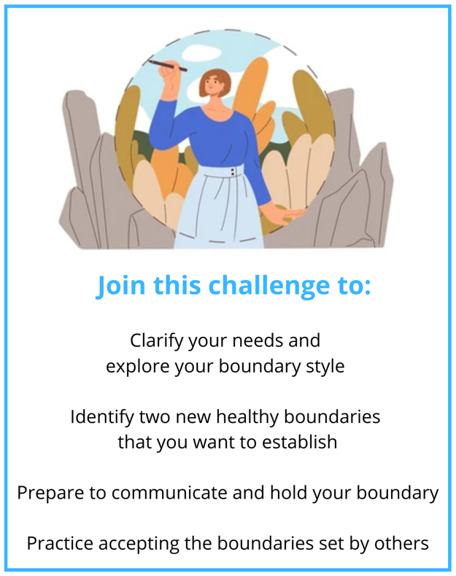
Participants who submit their challenge tracker to Human Resources by
[Insert Date] will be entered into a prize raffle for [Insert Raffle Prize].


