Subject Line: Master Your Money – Become Debt Free
Attachments:
- Week 4 Guide
- Expense Tracker Spreadsheet
- Challenge Tracker

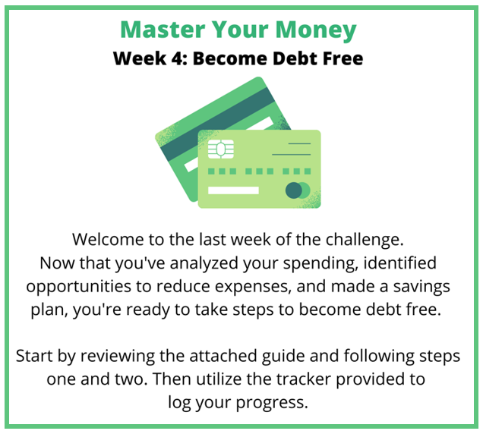

Submit your completed challenge tracker to Human Resources by [Insert Date] to be entered into a prize raffle for [Insert Raffle Prize].


