Subject Line:
Streaking Challenge – the finish line is in sight

Attachments:
- Week Four Guide
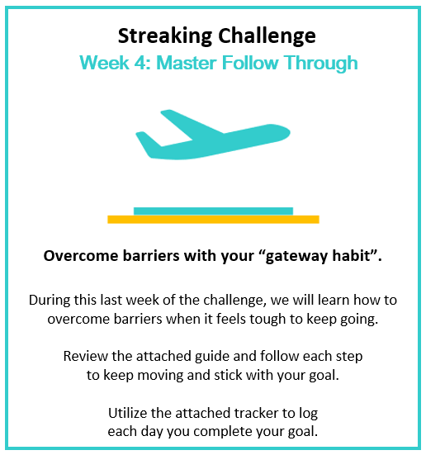
- Challenge Tracker

Submit your completed tracker to Human Resources by
[Insert Date] to be entered into a prize raffle for [Insert Raffle Prize].


