Subject Line:
Streaking challenge check-in: Reassess your goal

Attachments:
- Week Three Guide
- Challenge Tracker
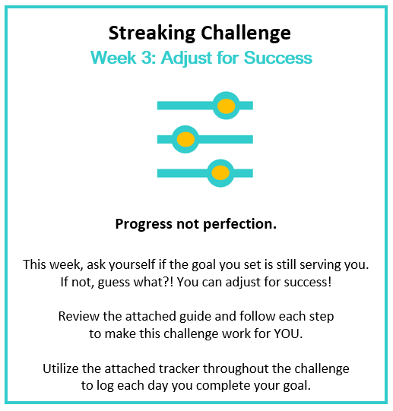
Submit your completed tracker to Human Resources by
[Insert Date] to be entered into a prize raffle for [Insert Raffle Prize].


