Subject Line:
Set your streaking goal

Attachments:
- Week One Guide
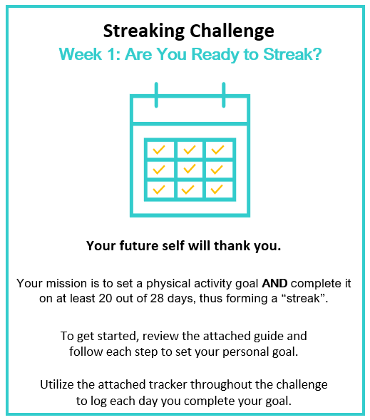
- Challenge Tracker
Submit your completed tracker to Human Resources by
[Insert Date] to be entered into a prize raffle for [Insert Raffle Prize].


