Subject Line:
Let the streaking begin!

Streaking Challenge
4-week fitness journey
Enter Dates
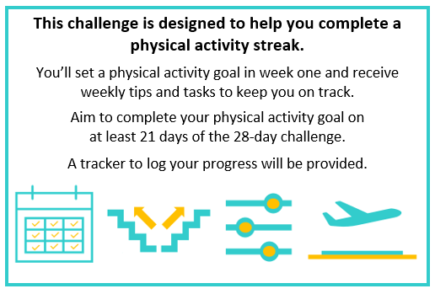
Submit your completed tracker to Human Resources by
[Insert Date] to be entered into a prize raffle for [Insert Raffle Prize].


