Subject Line:
Are you looking for a happiness boost? Join the Mindset Reset challenge!

Mindset Reset
4-week challenge
Enter Dates
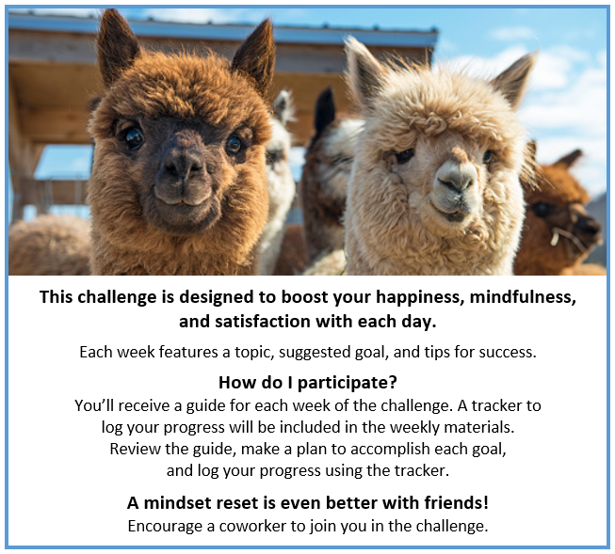
Participants who submit a completed challenge tracker to Human Resources

by [Insert Date] will be entered into a prize raffle for [Insert Raffle Prize].

