Subject Line:
What's for lunch this week?

Attachments:
- Week Two Guide
- Challenge Tracker
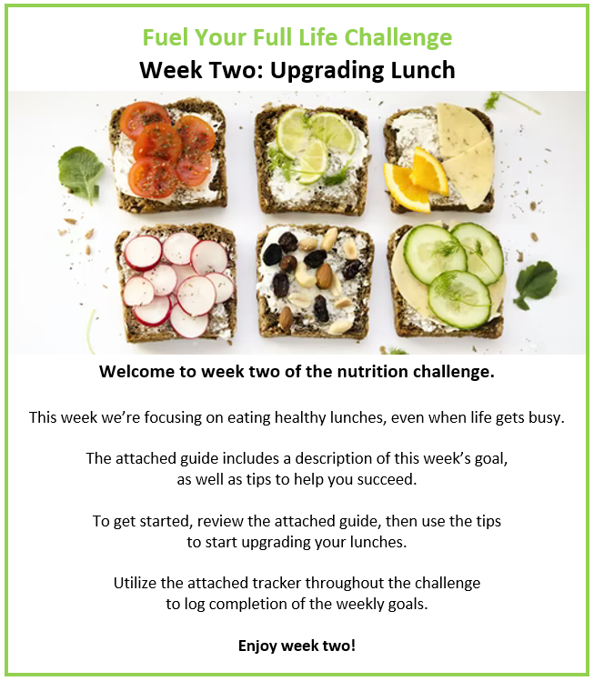
Participants who submit a completed challenge tracker to Human Resources
by [Insert Date] will be entered into a prize raffle for [Insert Raffle Prize].


