Subject Line:
It's thyme to cook, romaine calm!

Attachments:
- Week Four Guide
- Challenge Tracker
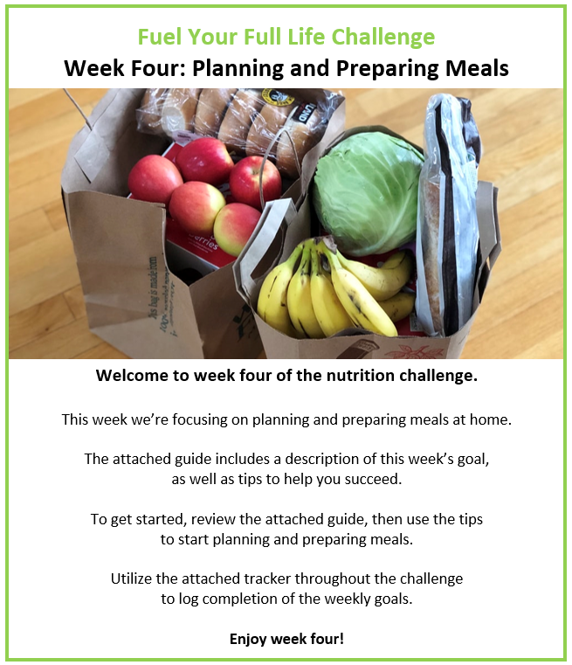
Participants who submit a completed challenge tracker to Human Resources
by [Insert Date] will be entered into a prize raffle for [Insert Raffle Prize].


