**Employee Wellness Action Plan**

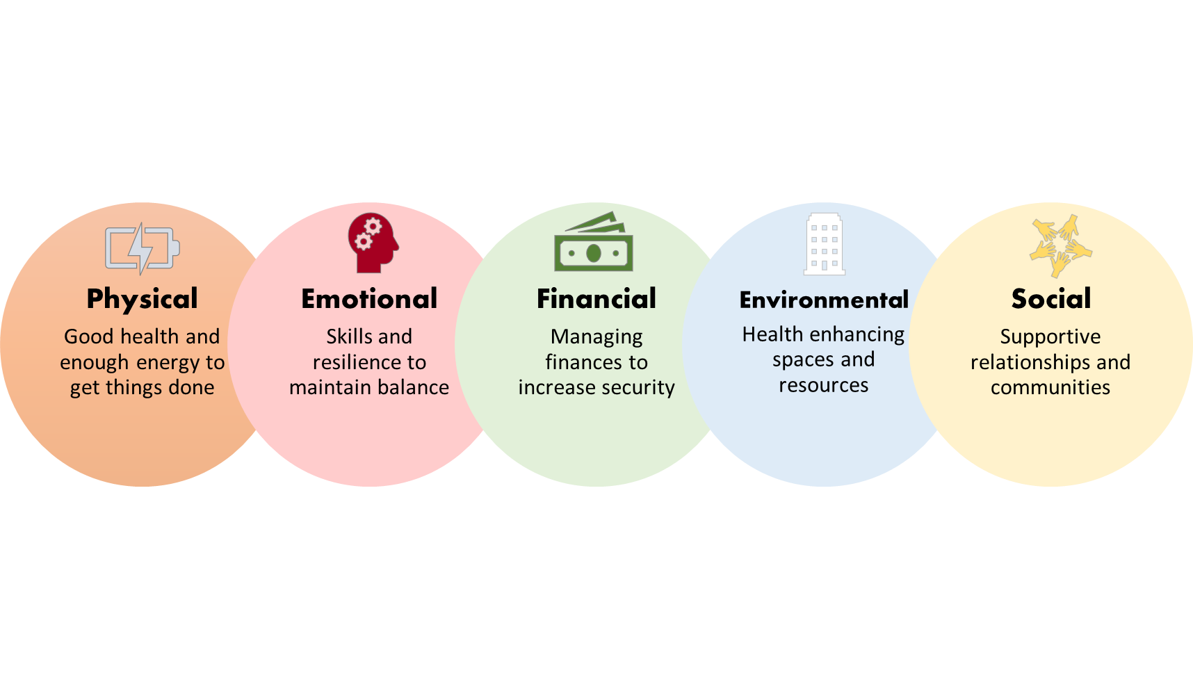

|  |  |  |  |  |  |
| --- | --- | --- | --- | --- | --- |
|  | **Physical** | **Emotional** | **Financial** | **Environmental** | **Social** |
| **Needs**: What are the employee needs and interests? |  |  |  |  |  |
| **Strategies**: How will employee needs and interest be addressed? |  |  |  |  |  |
| **Measures**: How will success be measured? |  |  |  |  |  |

**Employee Wellness Communication Calendar**

|  |  |  |  |  |
| --- | --- | --- | --- | --- |
|  | **Month** | **Strategy** | **Health Observance** | **Communication Channel** |
| Q1 | January |  |  |  |
| February |  |  |  |
| March |  |  |  |
| Q2 | April |  |  |  |
| May |  |  |  |
| June |  |  |  |
| Q3 | July |  |  |  |
| August |  |  |  |
| September |  |  |  |
| Q4 | October |  |  |  |
| November |  |  |  |
| December |  |  |  |

**Employee Wellness Budget**

|  |  |  |  |  |
| --- | --- | --- | --- | --- |
| **Item** | **Cost** | **Quantity** | **Subtotal** | **Notes** |
|  |  |  |  |  |
|  |  |  |  |  |
|  |  |  |  |  |
|  |  |  |  |  |
|  |  |  |  |  |
|  |  |  |  |  |
|  |  |  |  |  |
|  |  |  |  |  |
|  |  |  |  |  |
|  |  |  |  |  |
|  |  |  |  |  |
|  |  |  |  |  |
|  |  |  |  |  |
|  |  |  |  |  |
|  |  |  |  |  |
| **Total** |  |  |  |  |