Subject Line:
Want to improve your eating habits? Join the challenge starting [Enter Start Date]

Fuel Well for Your Full Life
4-week nutrition challenge
[Enter Challenge Dates]
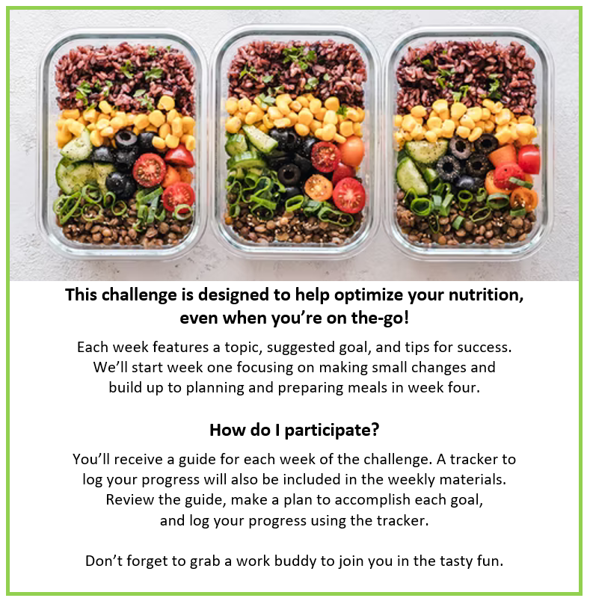
Participants who submit a completed challenge tracker to Human Resources
by [Insert Date] will be entered into a prize raffle for [Insert Raffle Prize].


