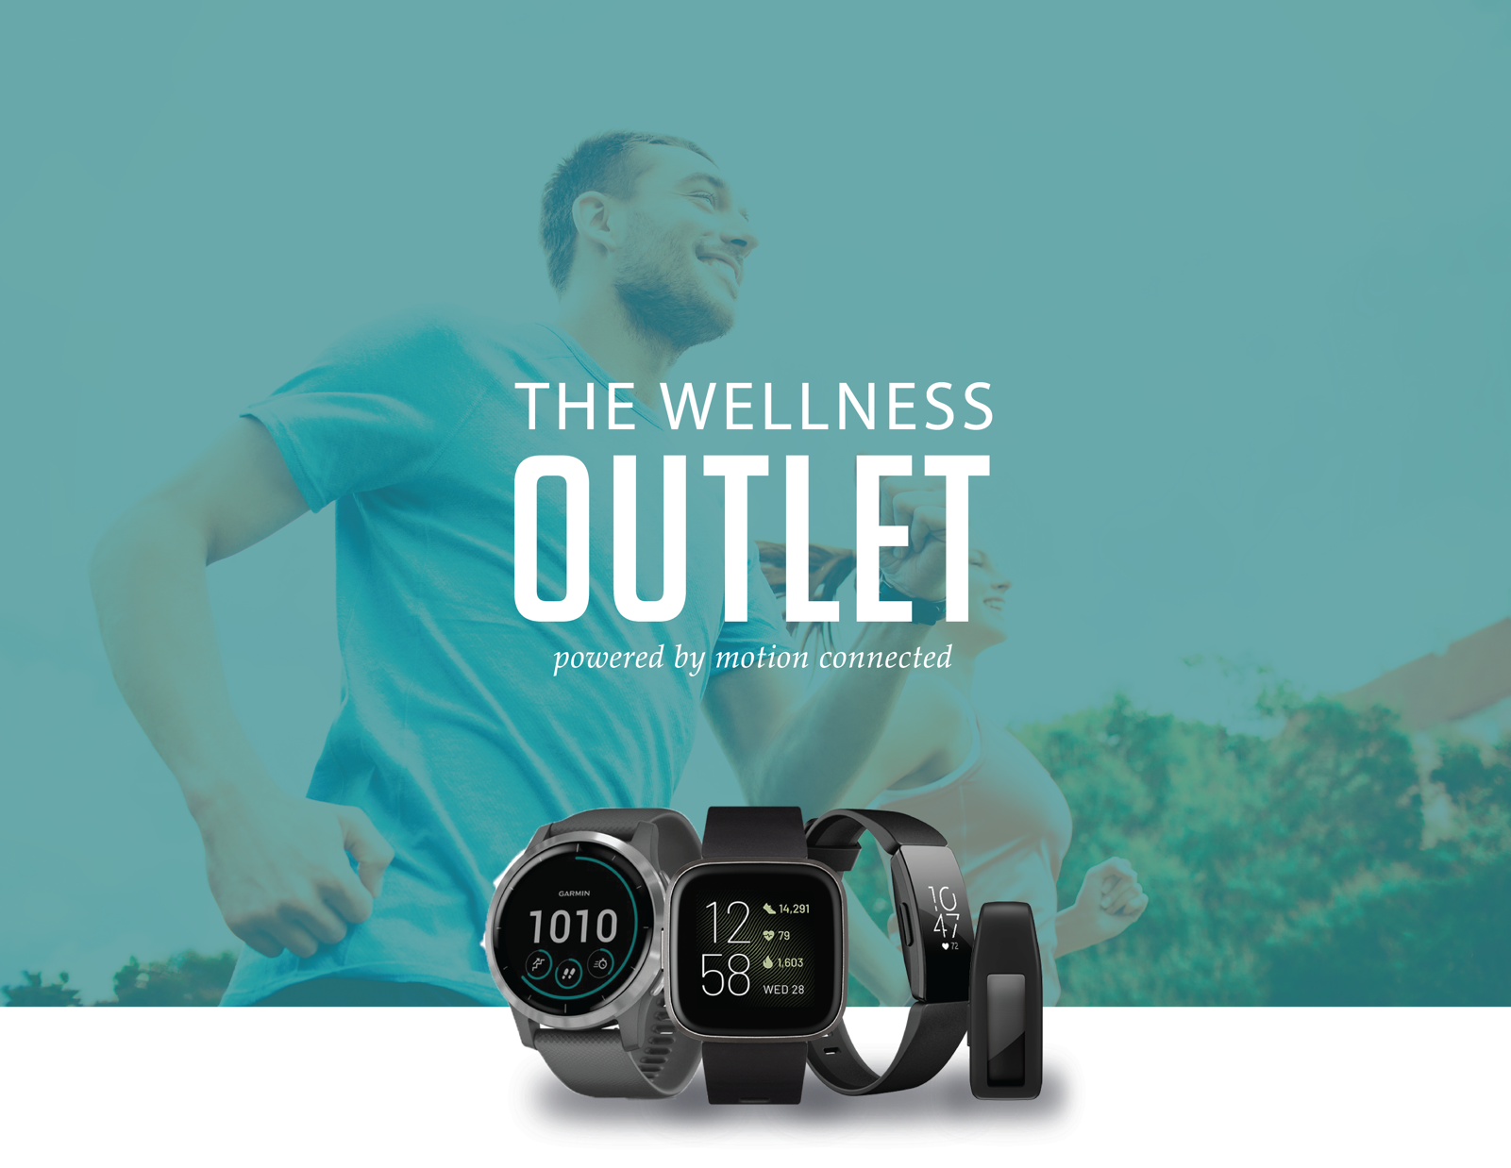

**Find the motivation to reach your health & fitness goals!**

**Create your Wellness Outlet Account:**

**Step 1**: Go to www.thewellnessoutlet.com

**Step 2:** Click on "Activate Account"

**Step 3:** Use the group code: **RICHARDSGRP**  
*(it IS case sensitive)*

**Step 4:** Login to your account to access discounted devices.



Wearable activity trackers are a great way to track your activity levels and inspire action.   
  
The Wellness Outlet offers discounted pricing on the latest Fitbit & Garmin devices. PLUS, get FREE shipping on all orders! Get the latest smart technology with GPS, heart rate, smart phone notifications and more.