

PayData’s evoPay - Employee Self Serve is a web-based portal which allows employees to access their payroll information via the internet. Employees have the ability to view and print payroll vouchers and W-2s, access their demographic data and view paid time-off balances. This paperless payroll system aids in reducing routine employee inquiries by granting employees greater access to payroll information, and eases the burden of distributing payroll vouchers to the work force.
The employee must register and create their ID prior to logging into evoPay for the first time.

Initial Login to evoPay

- Go to https://paydata.evolutionpayroll.com/ess#/login

- Click on the New User Register New tab. To enroll in evoPay you must utilize information from your last paystub. Secure a copy of the employee paystub and complete the following steps.

Login Name – This must be a unique identifying log in name, where spaces and characters are allowed but not required.
Password – Password – Passwords must be a minimum of 6 characters and include 1 letter, 1 number and 1 symbol.
Confirm Password – Enter the password again to verify that it is correct.
Company Code – 3379
Social Security – Enter your Social Security number without the dashes.
Check Number – Enter the check number of your last paycheck or direct deposit voucher, including the negative in front of the number. This is also found in the upper left hand section of your paystub. *Please ask Michele for this information.
Current Total Earnings – This amount can be found on your paystub located in the “Current” column \ “Total Earnings” row. You will need to subtract any taxable benefits from this amount. Taxable benefits are items that are added to your wages for taxation purposes, but not physically paid. (ex Group Term Life, Personal Use of Auto) *Please ask Michele for this information.
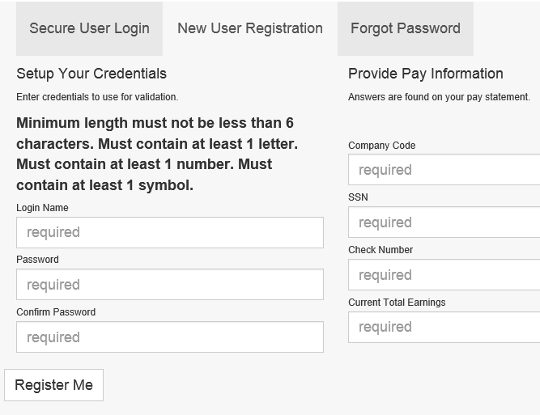

The first time you login you will need to setup your security questions and reset your password. Populate the answers, and click the black save disc in the upper left corner of the window.
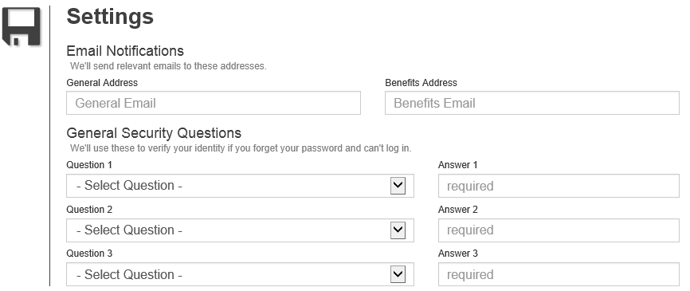

evoPay Dashboard Window

After successfully logging into evoPay, the initial Employee Self Service screen appears.

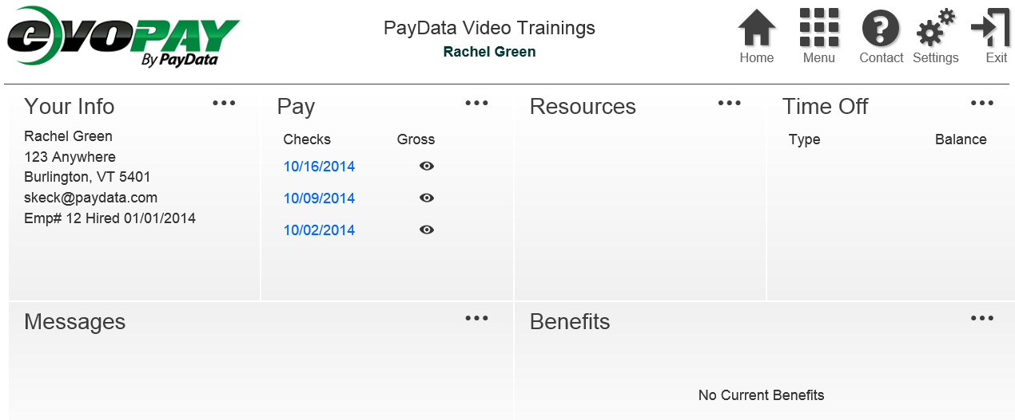

The Dashboard provides functionality for the employee to:
- View Primary Employee Demographics
- View messages setup by the evoPay Manager
- Access Pay Statements (Click the View symbol to view gross Amt)
- Resource links made available to all employees
- View Paid Time Off
- View benefit elections, if enabled.


Navigation through evoPay is accomplished by clicking the icon buttons from the top of the screen.
You can always access the main dashboard view by clicking the “Home” button.

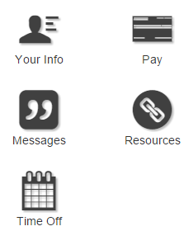
Clicking the Menu icon will provide a sub menu.

Your Info – Displays your employee demographics
Pay – Displays your full payroll history by check date
Messages – Displays messages from your employer
Resources – Displays links to commonly used websites
Time Off – Displays current balances, requests and allows
the user to create a new time of request.

Use the Your Info link form the Menu to access your demographics, pay rates, and make changes to your employee data. (Changes are enabled on some access levels. You may not have right to change your employee data.)
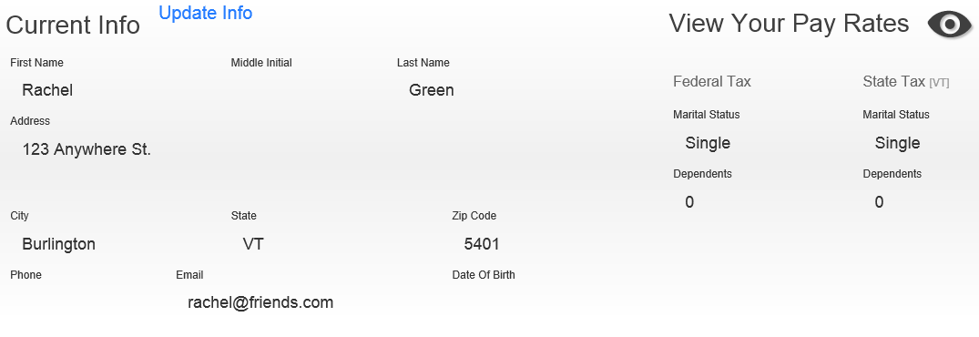

Use the Pay link from the Menu to access payroll data. By default, the current year payroll data is displayed. You can navigate through the years in the menu to identify older checks to view.

- Select the year button to view pay statements from a specific year.
- Click the check date to view the individual stub
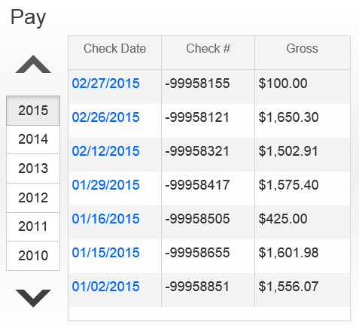
Sample Paystub

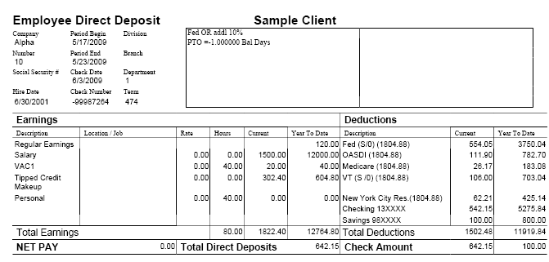

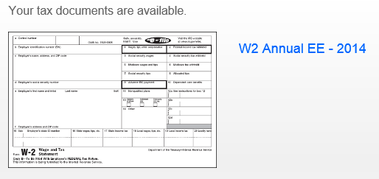
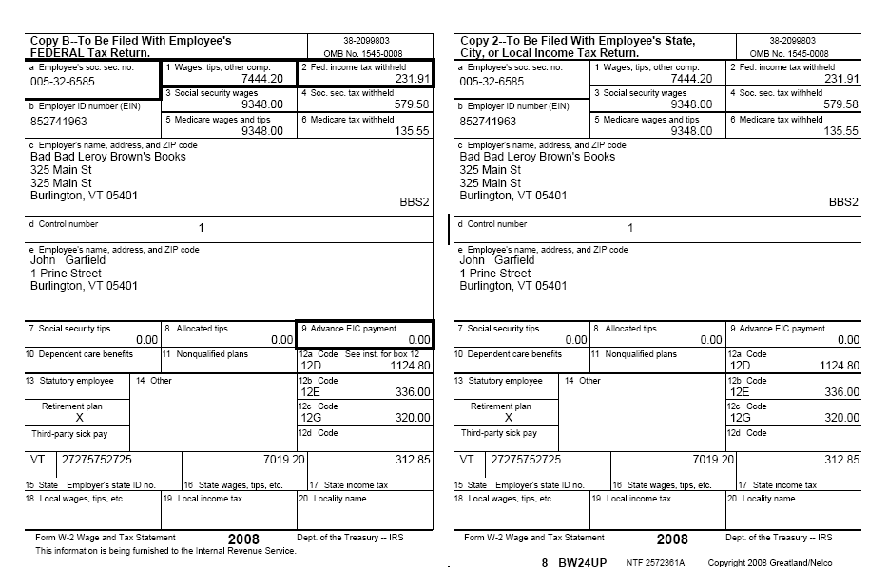
Within the Pay field, is a link to view your W2 for prior years. Click W2 Annual EE – 2014 (or other year) to view the document.

Sample W2 Form

Use the Messages link to view updates from your employer. These messages can change periodically, and are also available from the main dashboard view.

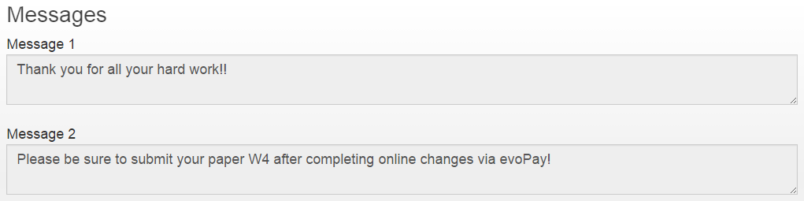

Use the Resources link to access commonly used websites, and directories provided by your employer
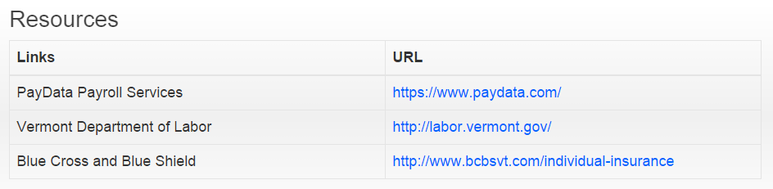

Use the Time Off link to view your available Paid Time Off balances, and request new time off for approval. (Not all employees are granted these rights. You may not have this option, or it may be a read only link. These parameters are decided by your employer)
Click on the Time Off Type from the left of the screen to view your balances in green. Click the Plus sign button at the top of the screen to make a new time off request.

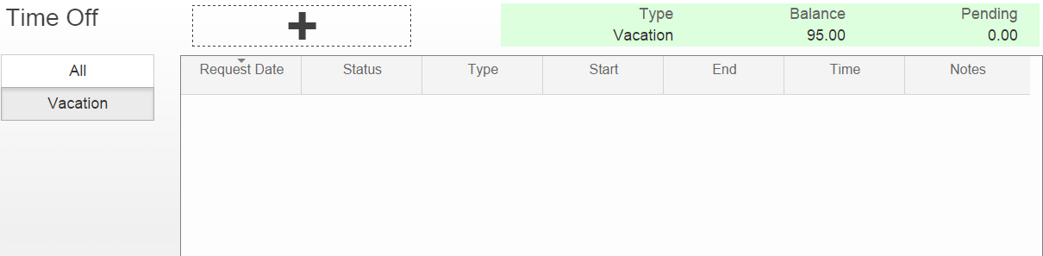

When making a new request for paid time off, be sure to identify the applicable dates, pay type and hours per day. You can identify specific minutes, as well as whether or not your request includes weekends. You can include a note regarding the request right on screen, and this will be submitted to your manager for review. Once complete, click the black disc in the left corner of the request window to submit your time off request to your manager.
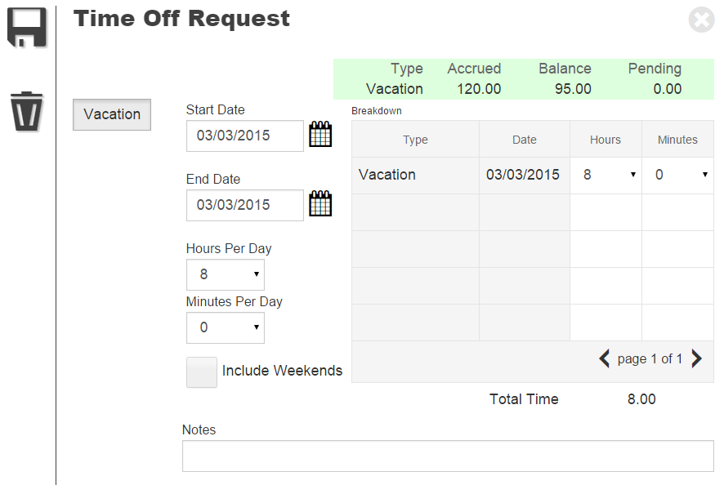

As soon as your request has been submitted, you’ll see a line item for the date(s) requested. This will remain in pending status until your manager approves, or declines the request.


Click the Contact icon to open the available phone number and email for your primary contact.
The email address that populates will open a new email using your default email program.
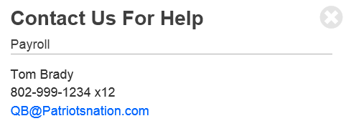


Select the Settings link to change or reset your evoPay password, email address, or security questions.
To make changes on this screen, you’ll need to populate your existing password in the New Password AND the Confirm Password fields:
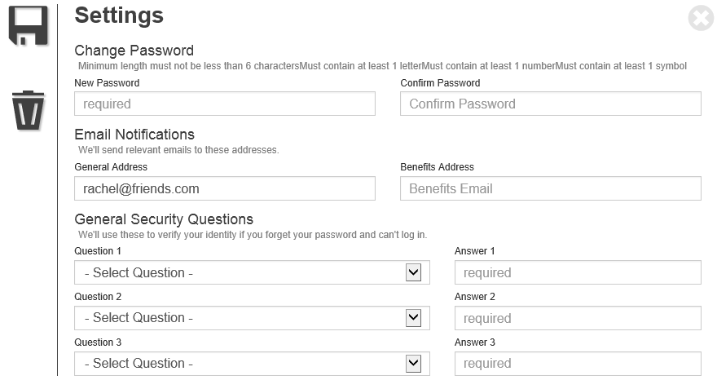

Click the black Disc to save your changed entries.

