

Using a Flexible Spending Account (FSA) is great way to stretch your benefit dollars. You use before-tax dollars in your FSA to reimburse yourself for eligible out-of-pocket medical and dependent care expenses. That means you can enjoy tax savings and increased take-home pay—all with the convenience of a prepaid benefits card.

WHAT IS AN FSA?

With an FSA, you elect to have your annual contribution (up to the $2,600 for a Healthcare FSA and up to $5,000 for a Dependent Care FSA) deducted from your paycheck each pay period, in equal installments throughout the year, until you reach the yearly maximum you have specified. The amount of your pay that goes into an FSA will not count as taxable income, so you will have immediate tax savings. FSA dollars can be used during the plan year to pay for qualified expenses and services.

- A Healthcare FSA allows reimbursement of qualifying out-of-pocket medical expenses.

- A Dependent Care FSA allows reimbursement of dependent care expenses, such as daycare) incurred by eligible dependents.

With all FSA account types, you’ll receive access to a secure, easy-to-use web portal where you can track your account balance, view your claims history and submit requests for reimbursements. In addition, you’ll receive a convenient prepaid benefits card to make it easy to pay for eligible services and products not covered by your health insurance. When you use this card, payments are automatically withdrawn from your account. Just swipe the card and go, it’s that easy! Save your receipts, while most expenses can be validated at the point of sale, you may be prompted to provide a copy of the receipt for certain transactions in accordance to IRS regulations. When required, receipts can easily be uploaded through our online consumer portal or through our mobile application. Its’s as simple as taking a picture of the receipt using the camera on your mobile device. 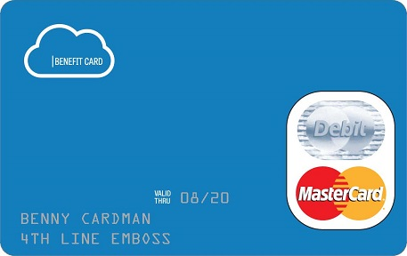
WITH AN FSA YOU CAN:
An FSA is a great way to pay for expenses with pre-tax dollars.
- Enjoy significant tax savings with pre-tax deductible contributions and tax-free reimbursements for qualified plan expenses
- Quickly and easily access funds using the prepaid benefits card at point of sale, or request to have funds directly deposited to your bank account via online or mobile app
- Reduce filing hassles and paperwork by using your prepaid benefits card
- Enjoy secure access to accounts using a convenient Consumer Portal available 24/7/365
- Manage your FSA “on the go” with an easy-to-use mobile app
- File claims easily online (when required) and let the system determine approval based on eligibility and availability of funds
- Stay up to date on balances and action required with automated email alert and convenient portal and mobile home page messages
- Get one-click answers to benefits questions
- Use it or Roll It Over and Grace Period. When you enroll in a Healthcare FSA your employer has two options when it comes to handling any unused funds that you may have at the end of a plan year. The first option is called a “Rollover Option” and that allows you as the employee up to $500 of your unused Healthcare Flexible Spending Account balance to be carried over into the next plan year instead of you “losing it”. The second option is called a “Grace Period” and that option allows for you the employee the ability to have up to an additional 2 ½ months beyond the end of the plan year to incur eligible Healthcare FSA expenses, giving you up to a maximum total of 14 ½ months to utilize your 12-month election. When enrolling in the Dependent Care FSA your employer can offer to allow you the same 2 ½ month Grace Period option that is available on the Healthcare FSA. These options give you more flexibility to spend your FSA money when you need it. You can use it for necessary out-of-pocket healthcare and dependent care expenses, rather than feeling pressured to engage in last minute and potentially unnecessary spending at the end of the year.
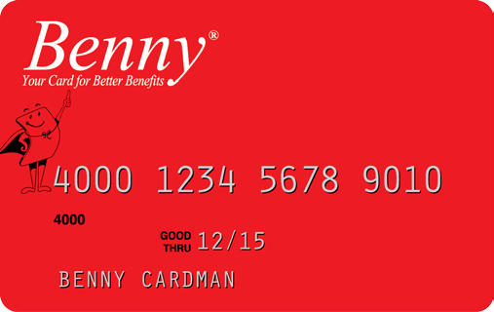

IS AN FSA RIGHT FOR ME?
An FSA is a great way to pay for expenses with pre-tax dollars.
A Healthcare FSA could save you money if you or your dependents:
- Have out-of-pocket expenses like co-pays, coinsurance, or deductibles for health, prescription, dental or vision plans
- Have a health condition that requires the purchase of prescription medications on an ongoing basis
- Wear glasses or contact lenses or are planning LASIK surgery
- Need orthodontia care, such as braces, or have dental expenses not covered by your insurance
A Dependent Care FSA provides pre-tax reimbursement of out-of-pocket expenses related to dependent care. This
benefit may make sense if you (and your spouse, if married) are working or in school, and:
- Your dependent children under age 13 attend daycare, after-school care or summer day camp
- You provide care for a person of any age whom you claim as a dependent on your federal income tax return and who is mentally or physically incapable of caring for himself or herself

PLAN AHEAD
Before you enroll, you must first decide how much you want to contribute to your account(s). You will want to spend some time estimating your anticipated eligible medical and dependent care expenses for the plan year.
Throughout the year, you’ll likely find yourself with expenses for yourself and your family that insurance won’t cover. By taking advantage of an FSA, you can actually reduce your taxable income and reduce your out-of-pocket expenses when you use your FSA to pay for the things you’d purchase anyway.

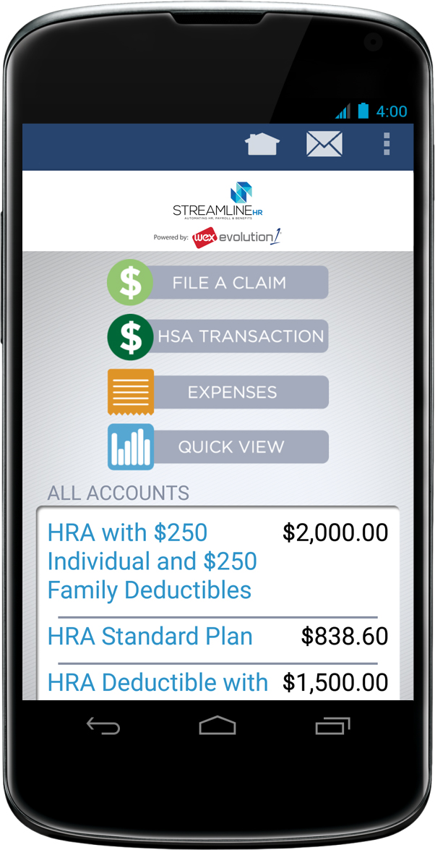

Above: With the convenience of a mobile device, you can see your available balance anywhere, anytime as well as file claims and upload receipts.

*The amount you save in taxes with a Flexible Spending Account will vary depending on the amount you set aside in the account; your annual earnings; whether or not you pay Social Security taxes; the number of exemptions and deductions you claim on your tax return; your tax bracket and your state and local tax regulations. Check with your tax advisor for information on how *The amount you save in taxes with a Flexible Spending Account will vary depending on the amount you set aside in the account; your annual earnings; whether or not you pay Social Security taxes; the number of exemptions and deductions you claim on your tax return; your tax bracket and your state and local tax regulations. Check with your tax advisor for information on how participation will affect your tax savings.

