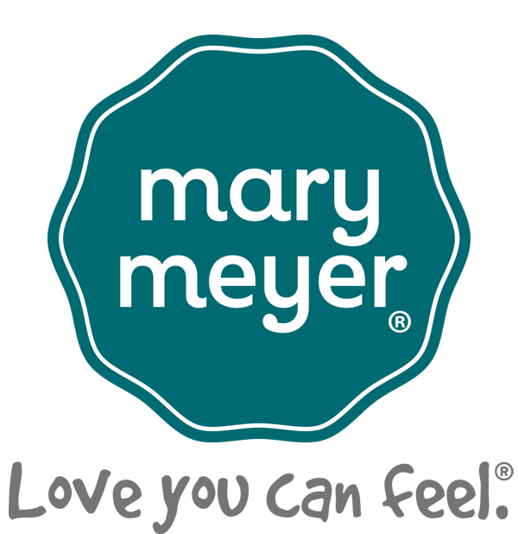

Mary Meyer Insurance Election Form

January 1 – December 31, 2025

Employee Name: ______________________________________________________________

Medical Plan with MVP Health Care

Elect GOLD 3 HDHP Medical Plan: Bi-Weekly Deduction:

I Elect SINGLE coverage $171.28
- I Elect EMPLOYEE/SPOUSE coverage $518.40
- I Elect EMPLOYEE/CHILDREN coverage $484.41
- I Elect FAMILY coverage $700.18

Elect BRONZE 3 HDHP Medical Plan: Bi-Weekly Deduction:

I Elect SINGLE coverage $17.73
- I Elect EMPLOYEE/SPOUSE coverage $211.31
- I Elect EMPLOYEE/CHILDREN coverage $188.07
- I Elect FAMILY coverage $268.72

Waive Medical Insurance:
- For My Child(ren)

- For My Spouse

- For Myself

Dental Plans with Northeast Delta Dental
BASIC PREMIUM

I Elect SINGLE coverage $17.76 $23.62
- I Elect TWO-PERSON coverage $32.53 $43.28
- I Elect FAMILY $57.17 $75.61

Waive Dental Insurance
- For My Spouse

- For My Child(ren)

- For Myself

Vision Plan with VSP
Bi-Weekly Deduction:

I Elect SINGLE coverage $7.63
- I Elect EMPLOYEE + 1 Dep. coverage $11.06
- I Elect EMPLOYEE + 2 Dep. or More coverage $19.84

Waive Vision Insurance
- For My Spouse

- For My Child(ren)

- For Myself

Health Savings Account (HSA)

Bi-Weekly Deduction:

I will contribute to my HSA through payroll deduction;

maximum $165.38 for single plans ($4,300 for the year); $_________

$328.85 for employees + dependents ($8,550 for the year)

I Waive contributing to my HSA at this time

Flexible Spending (FSA) and Dependent Care Accounts (DCA)
Bi-Weekly Deduction:

I will contribute to an FSA/LPFSA ($3,300 max, $126.93/bi-wkly) $_________

I Waive FSA/LPFSA participation

Bi-Weekly Deduction:

I will contribute to a DCA ($5,000 max or $192.30/bi-weekly) $_________

I Waive DCA participation

Additional Life Insurance

Note: you must cover yourself in order to cover your dependents; you can purchase spouse insurance up to 100% of the employee amount. You will need to complete the separate enrollment form if you wish to be covered by the additional life insurance benefits or make a change; see Gail in the Human Resources Office

I Already Participate and want to keep my current amounts of life insurance

I Newly Elect to Participate for myself in the amount of $_________

I Newly Elect to Participate for my spouse in the amount of $_________

I Newly Elect to Participate for my child(ren) in the amount of $_________

- I Waive Participation in the Voluntary Life Insurance Plan

Voluntary Accident Insurance
Bi-Weekly Deduction:

I Elect SINGLE coverage $4.58
- I Elect EMPLOYEE + Spouse $7.18
- I Elect Employee + Child(ren) $7.97
- I Elect EMPLOYEE + Family $10.66

Receipt of January 1, 2025 Benefit Forms:

By signing below, I acknowledge receiving the 2025 MVP plan SBCs, Compliance Notices and Mary Meyer Benefits at a Glance. I understand that if I wish to have a paper copy of any of our plan documents, I can get one from the Human Resources office. Also, my new payroll deductions will be taken from my paycheck starting the first payroll in January, 2025 for the elections above and I cannot change them unless I have a qualifying event (except HSA contributions).

________________________________ ______________________
Signature of Employee Date

